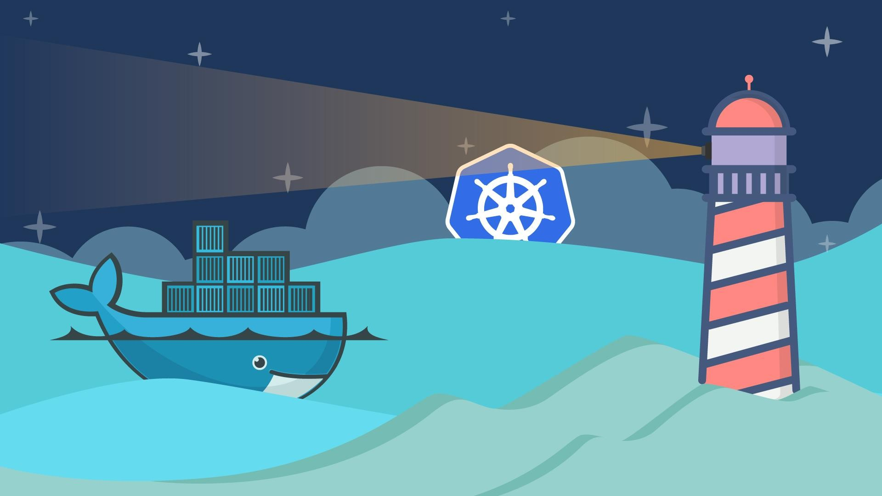

Introduction to

**Docker & Docker Swarm**

#### Vikram

IoT Application Dev

github.com/kunchalavikram1427

### The past and the present of Apps Deployment

Kubernetes

<https://www.edureka.co/blog/kubernetes-architecture/>

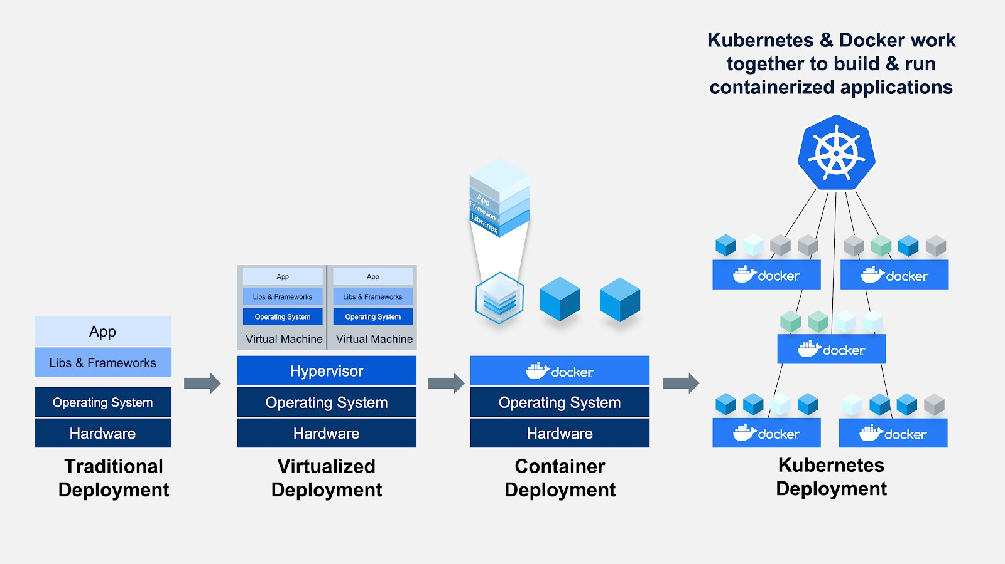

github.com/kunchalavikram1427

# A close up of a sign Description automatically generatedMonolithic Architecture

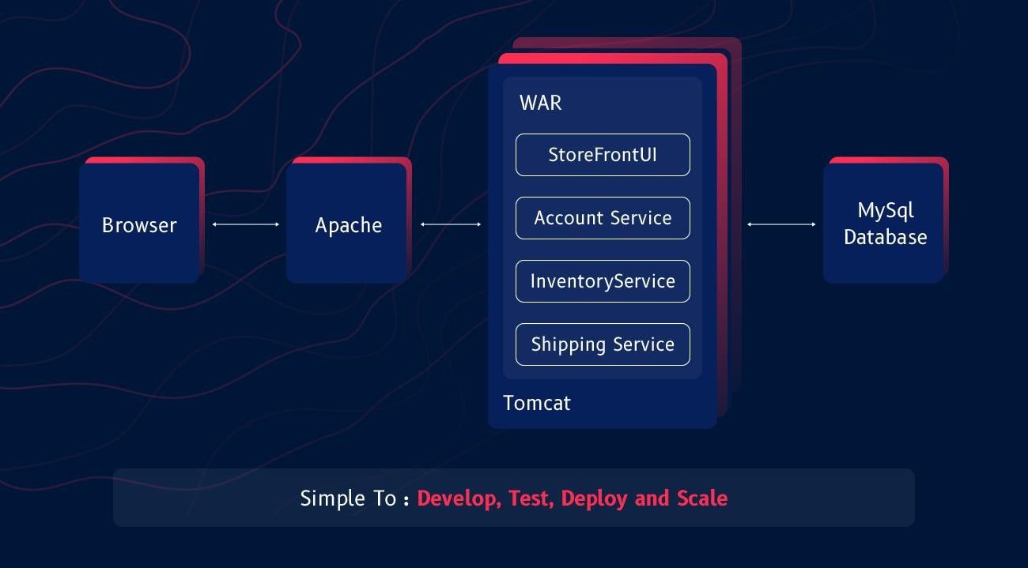github.com/kunchalavikram1427

# A close up of a sign Description automatically generatedMonolithic Architecture

* Different dependency requirements for each service
* Long setup times
* Different Dev/Test/Prod environments

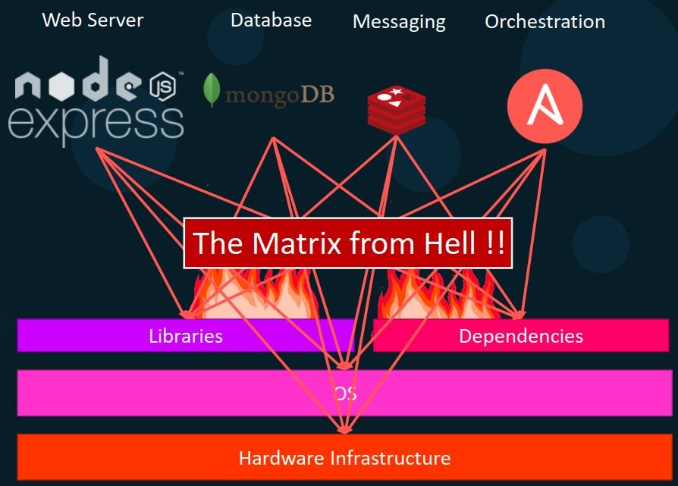Docker free course | KodeKloud.com

# Monolithic Applications

## Pros

* + Simple to develop
  + Simple to deploy – one binary
  + Easy Debugging & Error tracing
  + Simple to test
  + Less Costly

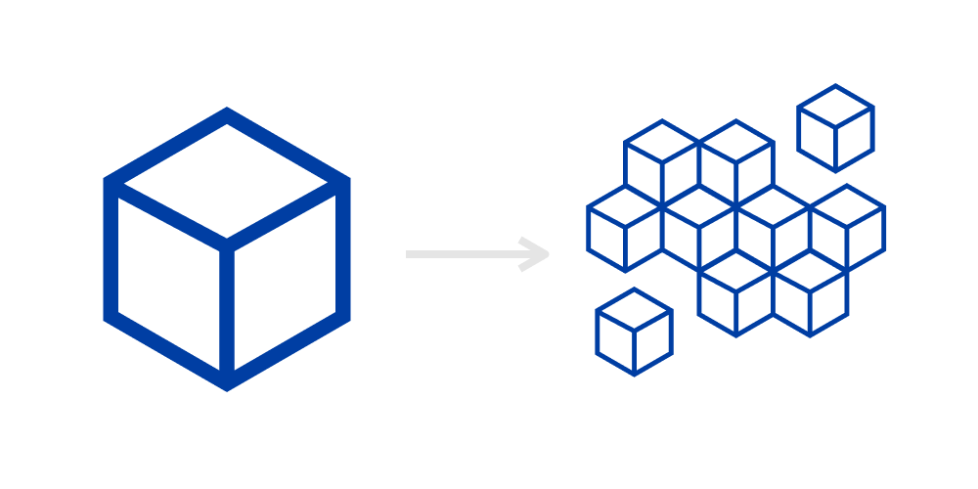

## A close up of a sign Description automatically generatedCons

• Difficult to understand and modify

• Tightly coupled

• Higher start-up and load times

• Redeploy the entire application on each update, and

also continuous deployment is difficult

• Less reliable: A single bug can bring down the entire application.

• Scaling the application is difficult

• Difficult to adopt new and advanced technology: Since changes in frameworks or languages will affect an entire application

• Changes are one section of the code can cause an

unanticipated impact on the rest of the code

<https://www.systango.com/blog/what-should-a-startup-choose-monolith-or-microservices-architecture/>

github.com/kunchalavikram1427

# A close up of a sign Description automatically generatedMicroservices Architecture

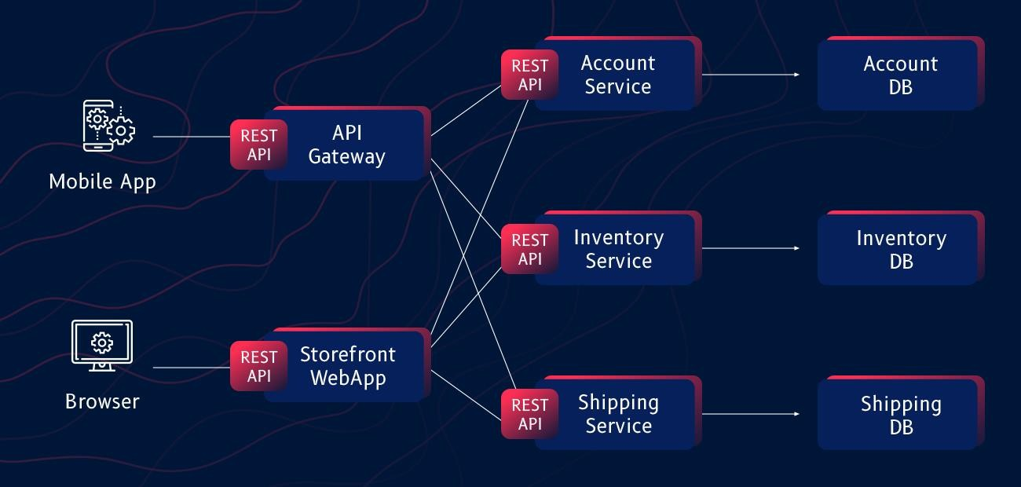github.com/kunchalavikram1427

# Microservices on VMs

## Hypervisor

• A hypervisor is software that creates and runs virtual machines (VMs) also known as guests

• It isolates the hypervisor operating system and resources from the virtual machines and enables the creation and management of those VMs

• The hypervisor treats host resources—like CPU, memory, and storage—as a pool that can be easily reallocated between existing guests or to new virtual machines

• Generally, there are two types of hypervisors

**Type 1** hypervisors, called “bare metal,” run directly on the host’s hardware. Ex: Microsoft Hyper-V or VMware ESXi hypervisor

**Type 2** hypervisors, called “hosted,” run as a software layer

on an operating system. Ex: VirtualBox, VMware Player

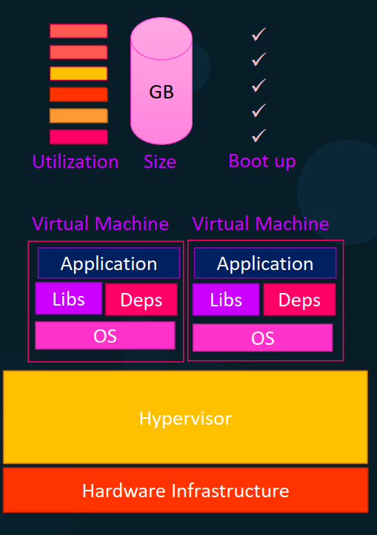github.com/kunchalavikram1427

# Microservices on VMs

• Run each service with its own dependencies in separate VMs

• Each VM has its own underlying OS and hosts a

Microservice

• Strong isolation and resource control between other VMs and host

• Each VM can have its own dependencies and libraries for the services. So different services across VMs can have different versions of same dependency

• Matrix from hell problem is no more

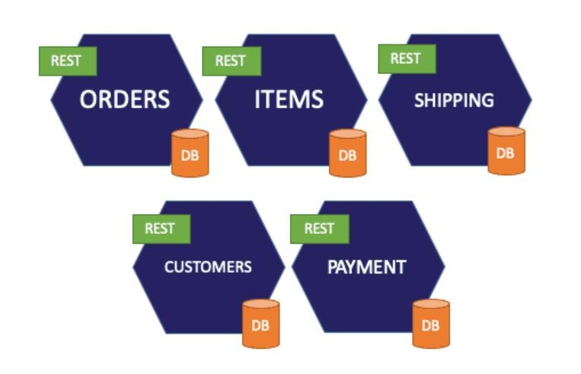

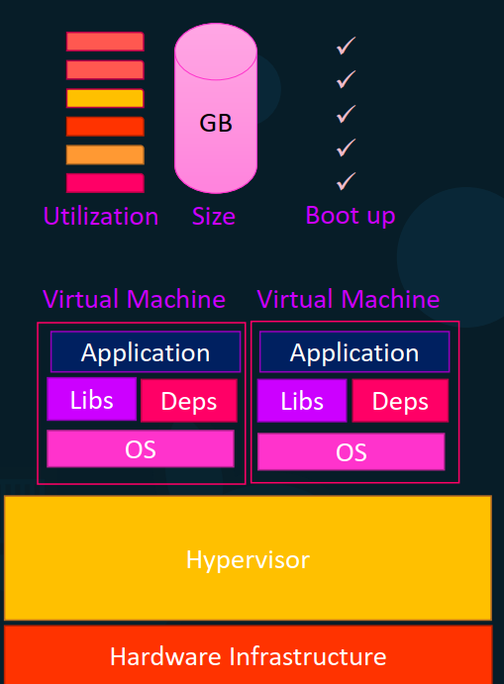github.com/kunchalavikram1427

# A close up of a sign Description automatically generatedMicroservices based Applications

## Pros

• Decoupled

• Ensures continuous delivery and deployment of large, complex applications.

• Better testing — since services are smaller and faster to test.

• Better deployments — each service can be deployed independently.

• No long-term commitment to technology – when developing a new service, you can start with a new technology stack.

## Cons

* Slow bootup times of VMs
* Increased memory consumption
* Large OS footprint
* Initial Costs are very High and this type of architecture demands for proficiency in the skills of the developers.
* Testing is difficult and time-consuming because there is an additional complexity involved because of the distributed system.
* Deployment Complexity – there is added operational complexity of deploying and managing a system that contains various service types.

github.com/kunchalavikram1427

Docker Containers



github.com/kunchalavikram1427

# Docker

Dev: It works fine in my system!

Tester: It doesn’t work in my system

## Before Docker

**A** developer sends code to a tester but it doesn’t run on the tester’s system due to various dependency issues, however it works fine on the developer’s end.

## After Docker

### **A**s the tester and developer now have the same system running on Docker container, they both are able to run the application in the Docker environment without having to face differences in dependencies issue as before.

github.com/kunchalavikram1427



github.com/kunchalavikram1427

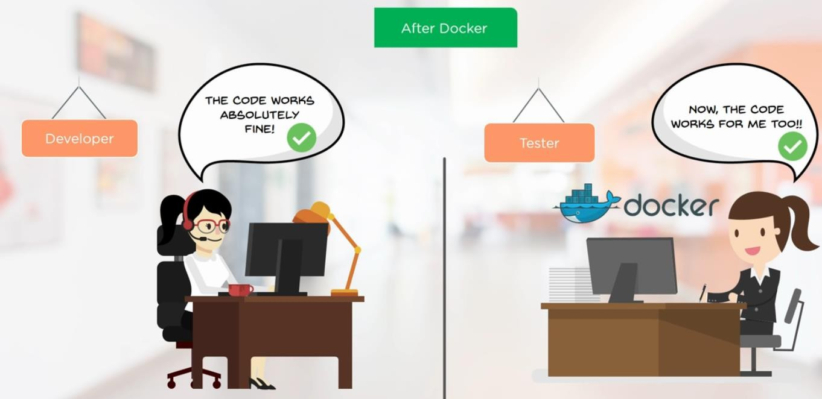

github.com/kunchalavikram1427

# Docker

github.com/kunchalavikram1427

Docker is a software development tool and a virtualization technology that makes it easy to develop, deploy, and manage applications by using containers.

Container refers to a lightweight, stand-alone, executable package of a piece of software that contains all the libraries, configuration files, dependencies, and other necessary parts to operate the application. They are the running instances of docker images.

Application

Dependencies

Ubuntu Base Image

Ex: Ubuntu + Python + Dependencies

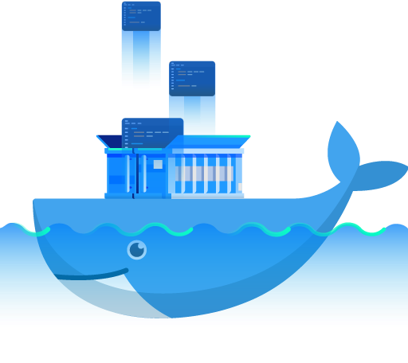github.com/kunchalavikram1427

# VMs vs Docker Containers

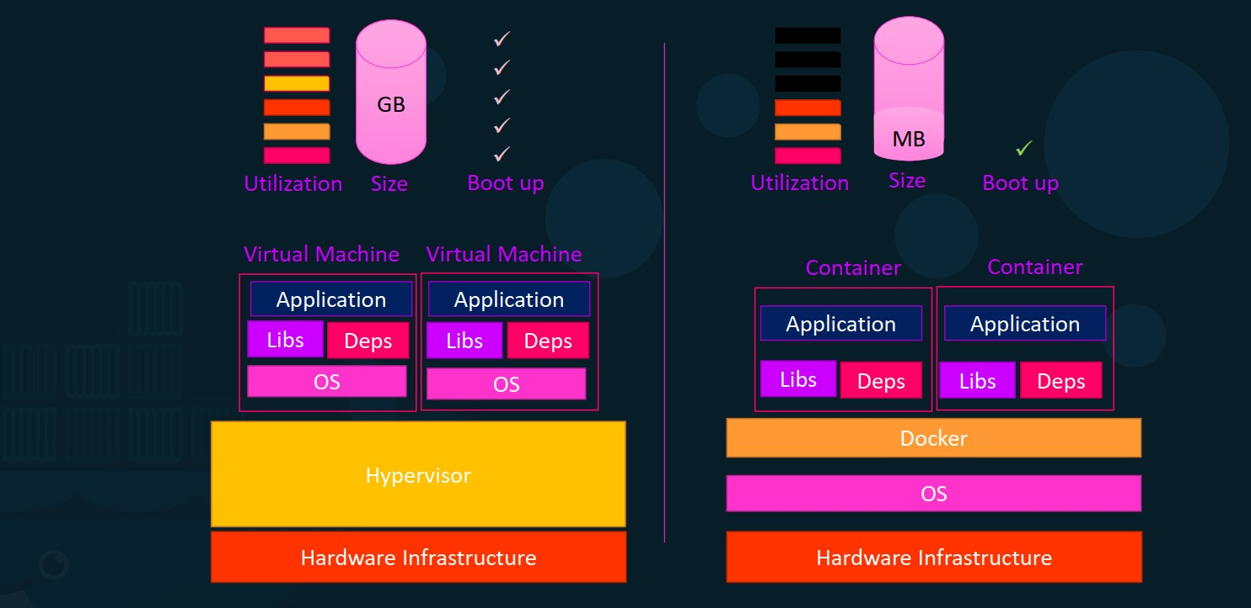

github.com/kunchalavikram1427

# A close up of a sign Description automatically generatedVMs vs Docker Containers

|  |  |
| --- | --- |
| **Virtual Machine** | **Docker Container** |
| Hardware-level process isolation | OS level process isolation |
| Each VM has a separate OS | Each container can share OS |
| Boots in minutes | Boots in seconds |
| VMs are of few GBs | Containers are lightweight (KBs/MBs) |
| Ready-made VMs are difficult to find | Pre-built docker containers are easily available |
| VMs can move to new host easily | Containers are destroyed and re-created rather than moving |
| Creating VM takes a relatively longer time | Containers can be created in seconds |
| More resource usage | Less resource usage |

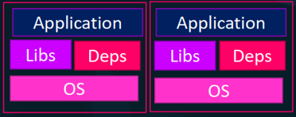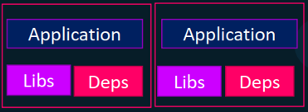github.com/kunchalavikram1427

# A close up of a sign Description automatically generatedDocker Architecture

### Docker uses a client-server architecture.

* + Docker client talks to the Docker daemon, which does the heavy lifting of building, running, and distributing your Docker containers

### Docker client and daemon can run on the same system, or you can connect a Docker client to a remote Docker daemon

* + For a virtual communication between CLI client and Docker daemon, a REST API is used

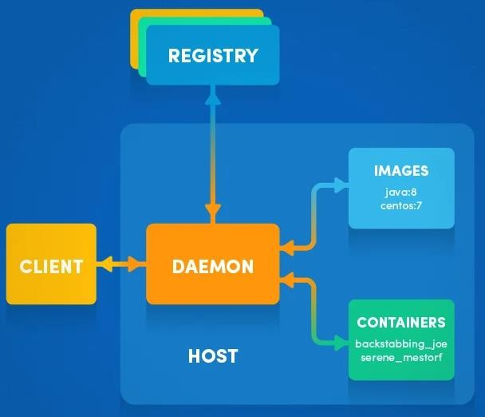

github.com/kunchalavikram1427

# Docker Architecture

github.com/kunchalavikram1427



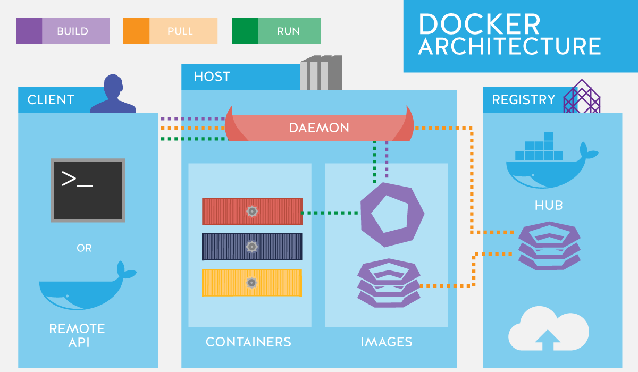

github.com/kunchalavikram1427

Docker Installation

### **Docker for Windows**: Win10 Pro/Ent only Uses Hyper-V with tiny Linux VM for Linux Containers

* **Docker Toolbox:** Win7/8/8.1 or Win10 Home Runs a tiny Linux VM in VirtualBox
* **Docker for MAC**
* **Docker for Linux**

Online Emulator: <https://labs.play-with-docker.com/>

https://docs.docker.com/get-docker/

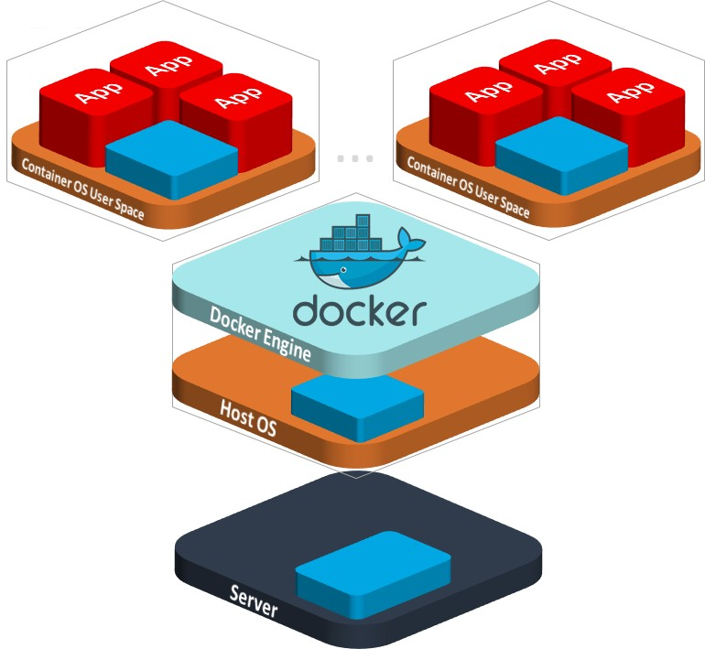

github.com/kunchalavikram1427

# Docker basic commands

github.com/kunchalavikram1427

### A close up of a sign Description automatically generateddocker version

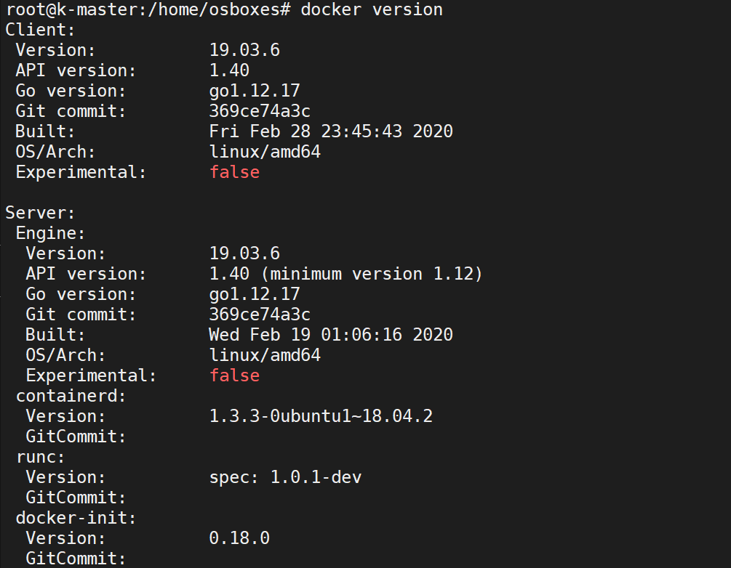github.com/kunchalavikram1427

# A close up of a sign Description automatically generatedDocker basic commands

### docker info

github.com/kunchalavikram1427

# A close up of a sign Description automatically generatedDocker Images & Containers

### Docker Image: Docker image can be compared to a template that is used to create Docker containers. These are read-only templates that contains application binaries and dependencies. Docker images are stored in the Docker Registry.

* + Docker Container: Docker container is a running instance of a Docker image as they hold the entire package needed to run the application.

Application

Dependencies

Ubuntu Base Image





Run

Docker Image

Container

github.com/kunchalavikram1427

# Docker Images & Containers

github.com/kunchalavikram1427

### A close up of a sign Description automatically generatedWe can run any number of containers based out of an image and Docker makes sure that each container created has a unique name in the namespace.

* + Docker image is a read-only template. Changes made in containers won’t be

### saved to the image by default

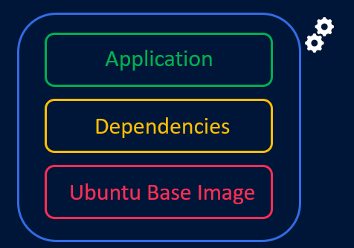Container 01

Container 02

Docker Image

Container 03

github.com/kunchalavikram1427

# A close up of a sign Description automatically generatedDocker Images & Containers

Containers run each service with its own dependencies in separate containers

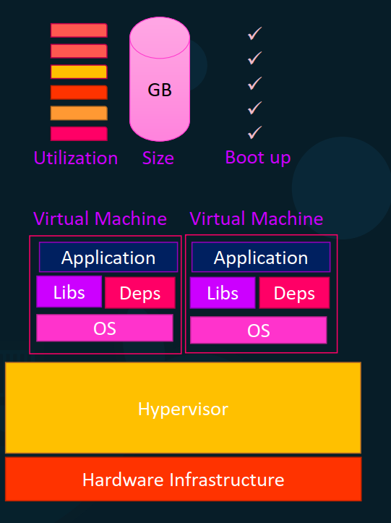github.com/kunchalavikram1427

# Union File System

github.com/kunchalavikram1427

### A close up of a sign Description automatically generatedA docker image is a read-only template for creating containers.

* + Changes made to the file system inside the running

### container won’t be directly saved on to the image.

* + Instead , if a container needs to change a file from the read-only image that provides its filesystem, it copies the file up to its own private read-write layer before making the change

### This is called copy-on-write (COW) mechanism.

* + These new or modified files and directories are 'committed' as a new layer.

### docker history command shows all these layers.

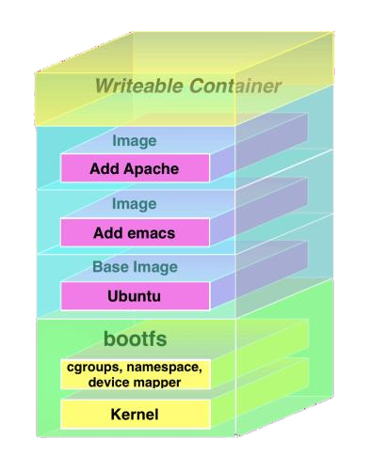github.com/kunchalavikram1427

# Docker Registry

github.com/kunchalavikram1427

### A close up of a sign Description automatically generatedDocker registry is a storage and distribution system for Docker images.

* + It is organized into Docker repositories , where a repository holds all the versions of a specific image.

### By default, the Docker engine interacts with DockerHub , Docker's public registry instance.

* + 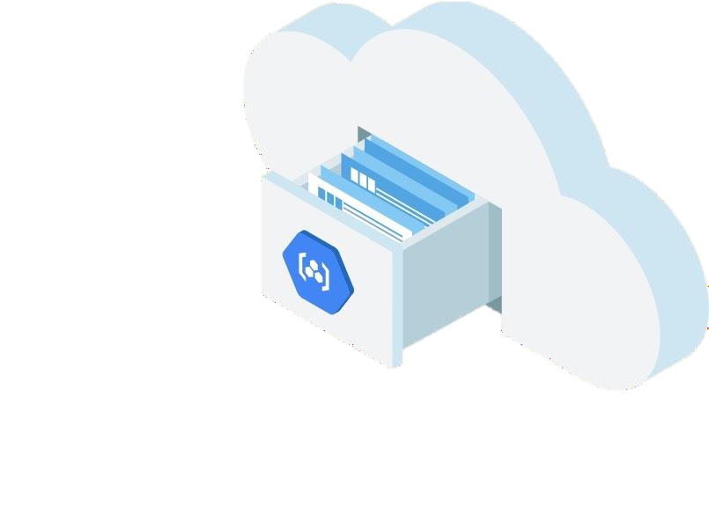However, it is possible to run on-premise private repositories Ex: Harbor

### Some Cloud Provider repos

* + - Amazon Elastic Container Registry

### Google Container Registry

* + - Azure Container Registry

github.com/kunchalavikram1427

github.com/kunchalavikram1427

# Docker Registry

* + <https://hub.docker.com/>

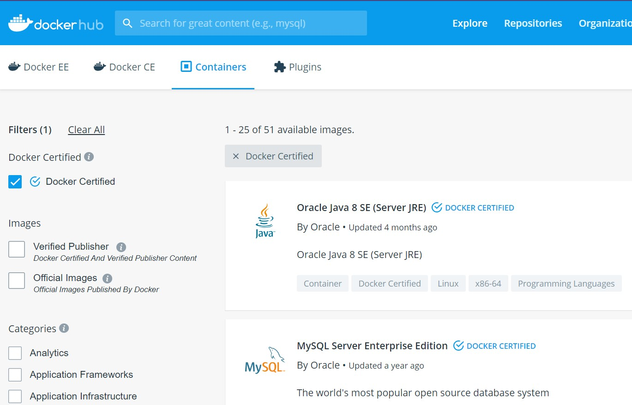github.com/kunchalavikram1427

# A close up of a sign Description automatically generatedDocker Registry

### Image name: username/image-name

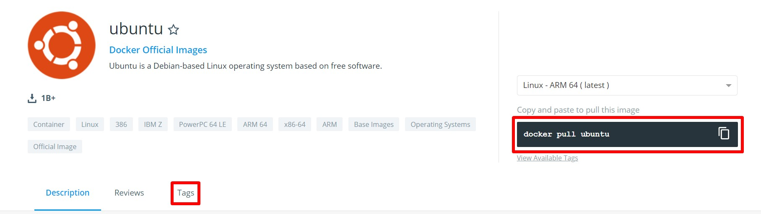

docker pull ubuntu:19.10

github.com/kunchalavikram1427

# Docker pull

github.com/kunchalavikram1427

### A close up of a sign Description automatically generatedBy default, docker pull will pull an image from docker hub. If you need to pull from a private repo, use repo URL

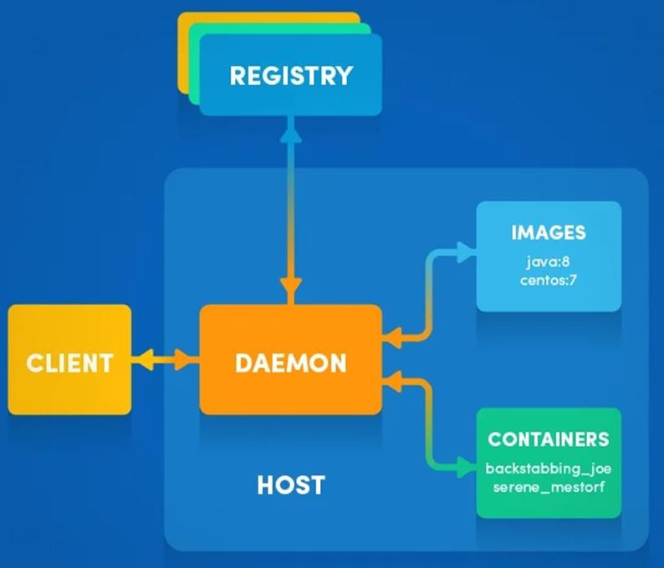docker pull myregistry.local:5000/testing/test-image docker pull ubuntu

root@k-master:/home/osboxes# docker pull ubuntu

Using default tag: latest

latest: Pulling from library/ubuntu d51af753c3d3: Pull complete fc878cd0a91c: Pull complete 6154df8ff988: Pull complete fee5db0ff82f: Pull complete Digest:

sha256:747d2dbbaaee995098c9792d99bd333c6783ce56150d1b11e3 33bbceed5c54d7

Status: Downloaded newer image for ubuntu:latest

github.com/kunchalavikram1427

github.com/kunchalavikram1427

# Docker pull

### docker images

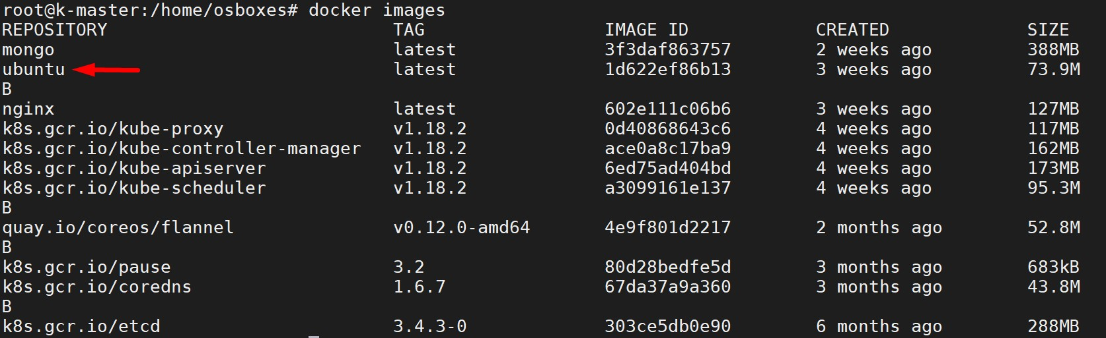

github.com/kunchalavikram1427

# Docker home directory

github.com/kunchalavikram1427

### A close up of a sign Description automatically generated/var/lib/docker

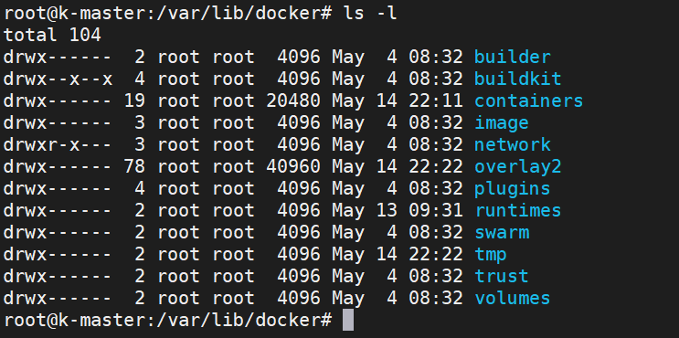

docker stores all the images, containers, volumes, networks information in it’s default home

directory github.com/kunchalavikram1427

# Docker basic commands

github.com/kunchalavikram1427 github.com/kunchalavikram1427

Format: docker <command> <sub-command>

docker image ls

### docker help

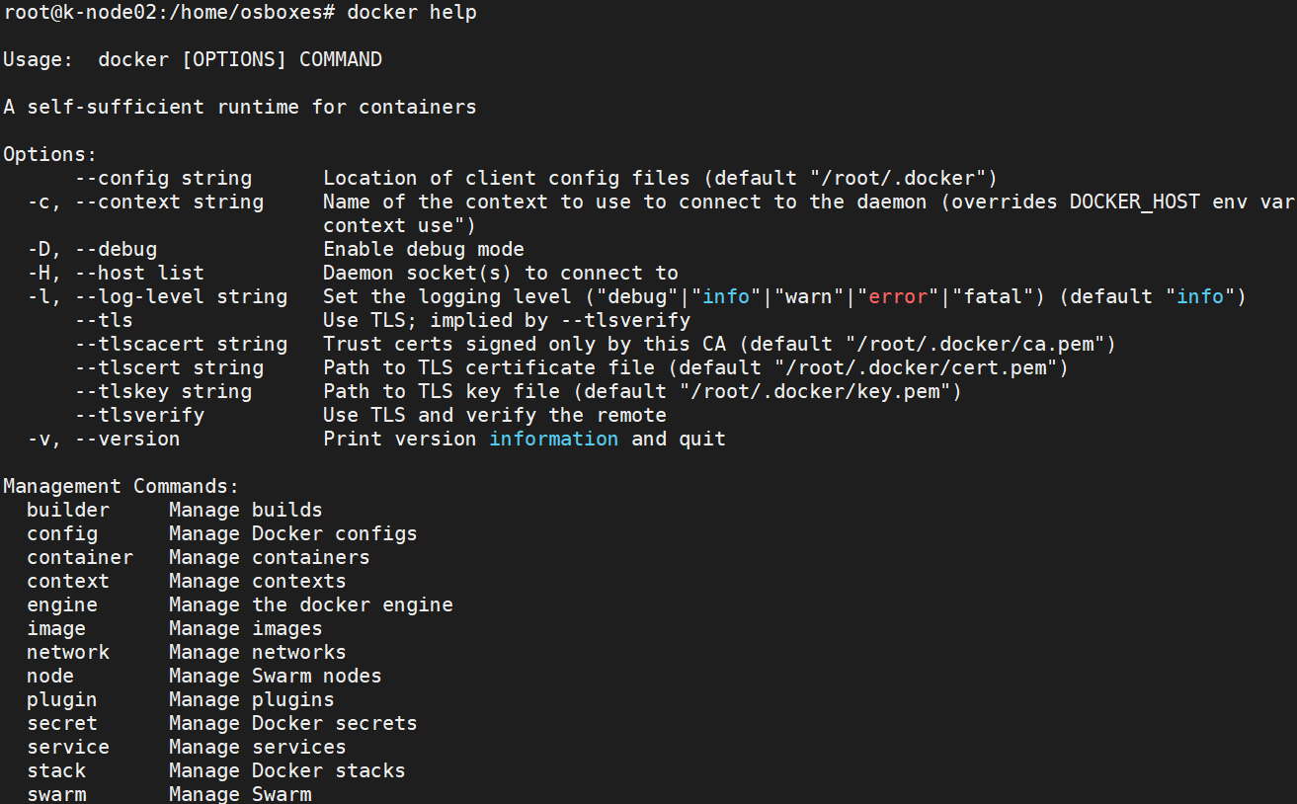github.com/kunchalavikram1427

# A close up of a sign Description automatically generatedDocker basic commands

docker <command> <sub-command> docker image --help

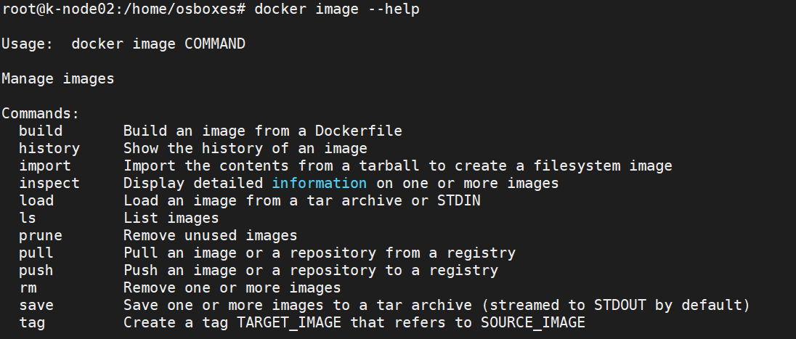

docker image ls

github.com/kunchalavikram1427

github.com/kunchalavikram1427

# Docker Container basics

### Running a container docker container run nginx

What happens in 'docker container run'

1. Docker looks for that image locally in image cache
2. If it doesn't find anything, it looks in remote image repository
3. Downloads the latest version (latest version by default)
4. Creates new container based on that image and prepares to start
5. Container gets attached to a network and gets a virtual IP inside the private network, typically default bridge network
6. Opens up ports to serve the requests
7. Starts process mentioned in the CMD of image’s Dockerfile

**NGINX** is open source software for web serving, reverse proxying, caching, load balancing, media streaming, and

more

github.com/kunchalavikram1427

# Docker Container basics

github.com/kunchalavikram1427

### A close up of a sign Description automatically generateddocker run nginx



Container

Docker host

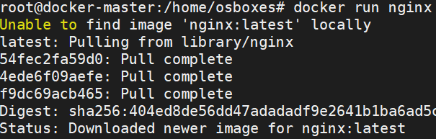

* + When we run nginx, a container is created out of the nginx image
  + The container runs in the foreground and current terminal gets attached to it. If we try to come out of the terminal by doing ctrl + c, the container terminates/killed
  + To avoid this we need to run the container in detached(background) mode using

–detach.

docker run --detach nginx

github.com/kunchalavikram1427

# Docker Container basics

github.com/kunchalavikram1427

### A close up of a sign Description automatically generateddocker ps list all running containers



docker ps –a list all running and exited containers

### docker container inspect <container-id> - gives the config and meta data used to start this container; returns JSON array

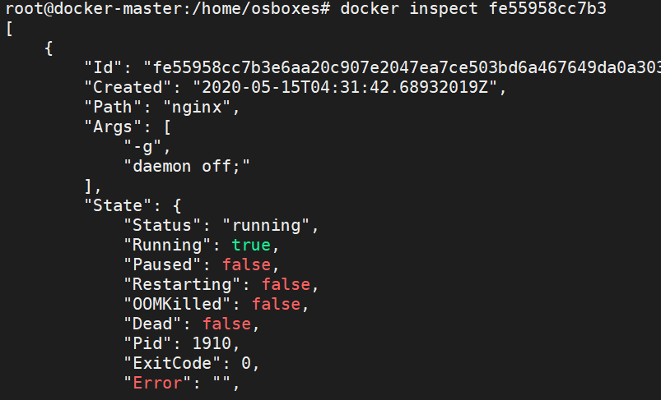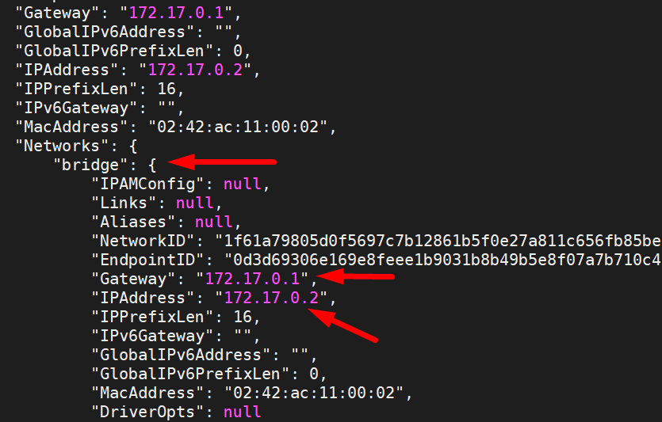github.com/kunchalavikram1427

github.com/kunchalavikram1427

# Docker Container basics

### curl <ip-of-container>



80

Container

172.17.0.2

Docker host/VM

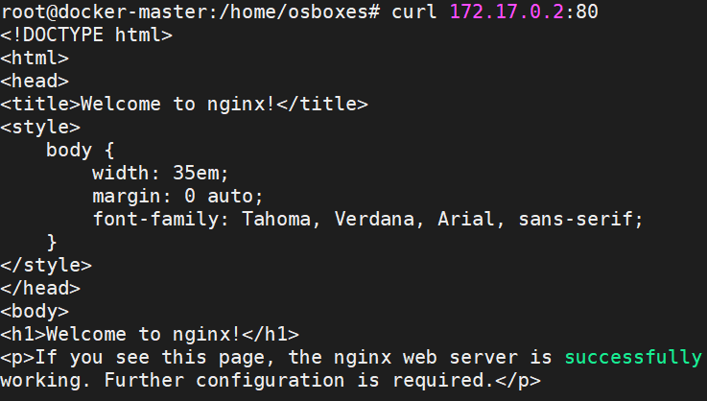192.168.0.3

You can also find IP by running below command with container ID as argument

root@docker-master:/home/osboxes# docker container inspect --format '{{.NetworkSettings.IPAddress}}’ fe559 172.17.0.2

It is not necessary to use complete container ID everytime, first few unique characters should be fine.

Applies for other objects like volumes, networks, images etc.

github.com/kunchalavikram1427

# A close up of a sign Description automatically generatedDocker Container basics: Port Mapping

### curl <ip-of-container>



80

Container

172.17.0.2

Docker host/VM

8080

 192.168.0.3

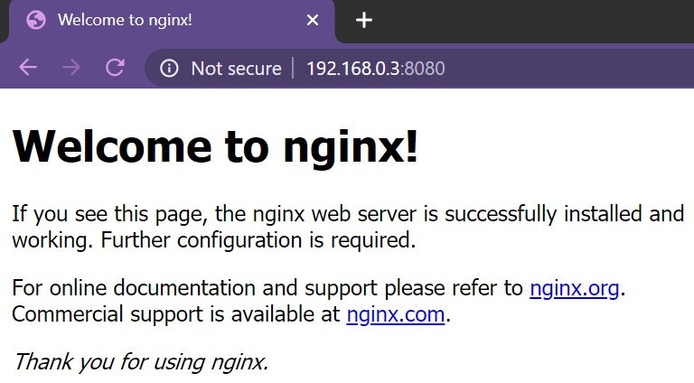docker run --detach –p 8080:80 nginx

github.com/kunchalavikram1427

# Docker Container

* + Name a container: docker run --detach –p 8080:80 --name webhost nginx
  + Stop a container: docker container stop <unique container id>
  + Start a stopped container: docker start < unique container id>
  + Kill a container: docker container kill <unique container id>
  + Logs: docker container logs <container name>

docker container logs -f <container name>

* + Remove a container: docker container rm <container name>
  + Lists specific processes in a specific container docker top <container>
  + Get CPU, Mem usage of the container docker container stats <container>

80

Container

172.17.0.2

Docker host/VM



192.168.0.3

8080

github.com/kunchalavikram1427

github.com/kunchalavikram1427

# Docker Container: Getting shell access

### Start new container interactively: Getting container’s shell access

docker container run -it <container-name> bash docker container run -it --name ubuntu bash



Container

172.17.0.2

Docker host/VM

-i : interactive or STD_IN

-t : terminal or STD_OUT

192.168.0.3

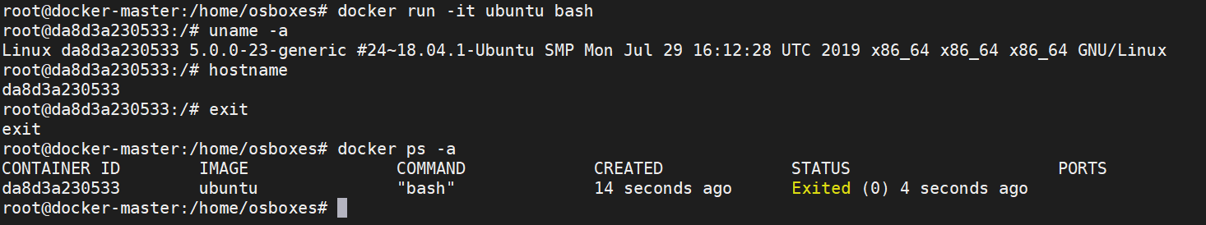

github.com/kunchalavikram1427

# A close up of a sign Description automatically generatedDocker Container: Getting shell access

### Importance of -i -t flags

Any image that has shell as its starting process expects a terminal(-t)



Container

172.17.0.2

Docker host/VM

and standard input(-i) to be attached when starting the container.

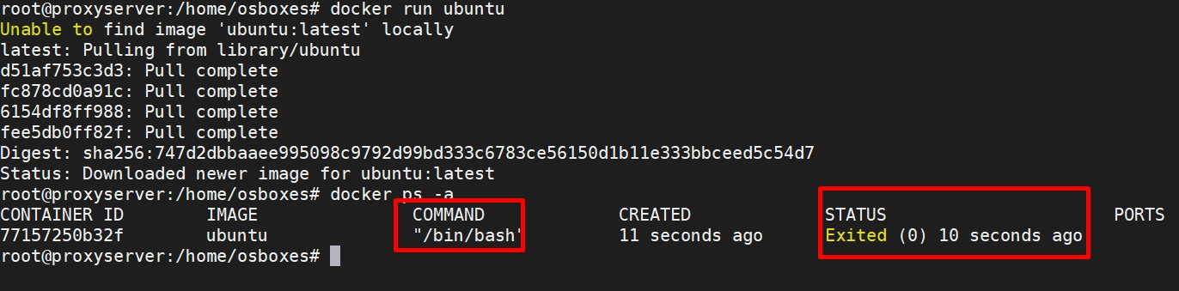If the container doesn’t find the terminal, it simply exits.

192.168.0.3

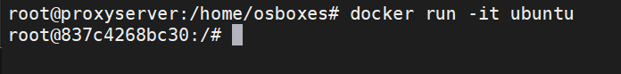

You can override default CMD of the image by passing additional arguments while running the image. Ex: docker run –d ubuntu sleep 1000 .In this case the default bash command is overridden

Refer Dockerfile section of this document for more information

github.com/kunchalavikram1427

# A close up of a sign Description automatically generatedDocker Container: Getting shell access

### Containers are not full fledged operating systems

* + They are meant to run a specific process/application

### Containers run as long as process inside them is alive. When process completes, the container simply exits

* + Ubuntu runs bash as the starting process. When bash process is terminated, the container gets terminated.

Use image inspect to find default CMD of the image docker image inspect ubuntu



Container

172.17.0.2

Docker host/VM

192.168.0.3

github.com/kunchalavikram1427

# Docker Container

github.com/kunchalavikram1427

### A close up of a sign Description automatically generatedInteracting with the running container

* + Use exec to interact with a running container docker run -it -d --name centos centos docker exec -it centos bash



Container

172.17.0.2

Docker host/VM

### Commit changes in container to a image

* + By default changes made to container are lost once container is deleted, to preserve the changes, commit to an image

docker commit <container-id> <new-image-name>

192.168.0.3

github.com/kunchalavikram1427

# Docker Networking

github.com/kunchalavikram1427

### A close up of a sign Description automatically generatedDocker gives 3 default networks: bridge, none and host

* 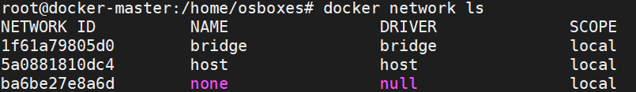When you start Docker, a default bridge network (also called bridge) is created automatically, and newly-started containers connect to it unless otherwise specified.

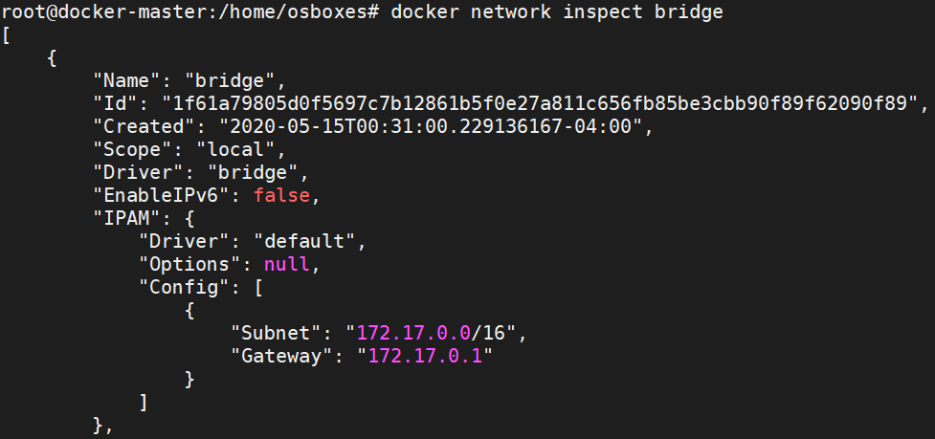docker network ls

docker network inspect bridge

github.com/kunchalavikram1427

# A close up of a sign Description automatically generatedDocker Networking: Bridge

* 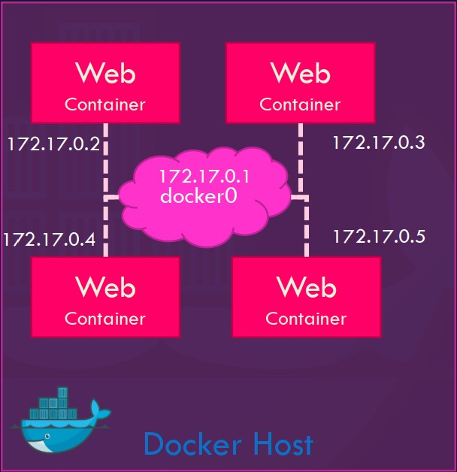In Bridge network, all containers get private internal IPs and they are isolated from host.
* Port forwarding forwards outside traffic to the containers.
* Containers on the default bridge network can only access each other by IP addresses, unless you use the --link option, which is considered legacy
* You can also create user-defined custom bridge network
* User-defined bridge networks are superior to the default bridge network
* On a user-defined bridge network, containers can resolve each other by name or alias(DNS)

### Create a bridge network: docker network create --driver bridge my-net Attach a container to it: docker run -d --name web --net my-net nginx

github.com/kunchalavikram1427

# Docker Networking: Bridge

github.com/kunchalavikram1427

Understanding DNS resolution in bridge network

* + When containers are run in default bridge network they cannot find each other using their container names.
  + Simply put, DNS resolution through container names will not work under default bridge network

In the below example, 2 containers are created under the default bridge network

Note that ping to second container from the first container using the second container’s name didn’t resolve(DNS server is not

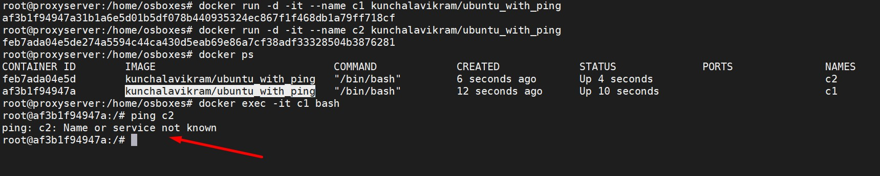available under default bridge network)

github.com/kunchalavikram1427

# Docker Networking: Bridge

github.com/kunchalavikram1427

Understanding DNS resolution in bridge network

* + Now a new bridge network is created and containers are attached to that network using --net flag
  + In this case, containers find each other using their container names(DNS resolution through container names)

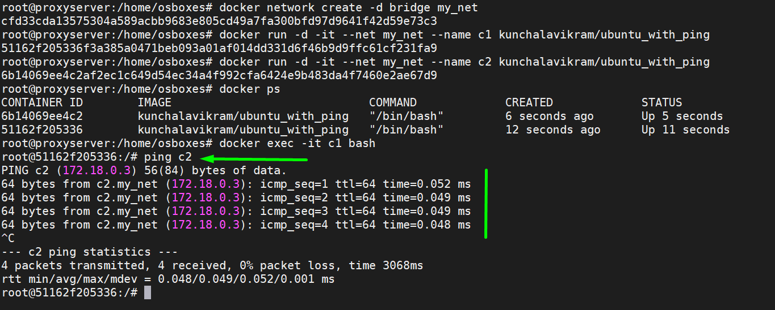github.com/kunchalavikram1427

# A close up of a sign Description automatically generatedDocker Networking: Port Mapping



### Port forwarding enables access to applications running inside containers from outside world

192.168.0.3:80

### docker run –p 80:5000 nginx docker run –p 8000:5000 nginx docker run –p 8001:5000 nginx docker run –p 3306:3306 mysql docker run –p 8306:3306 mysql docker run -p 8306:3306 mysql

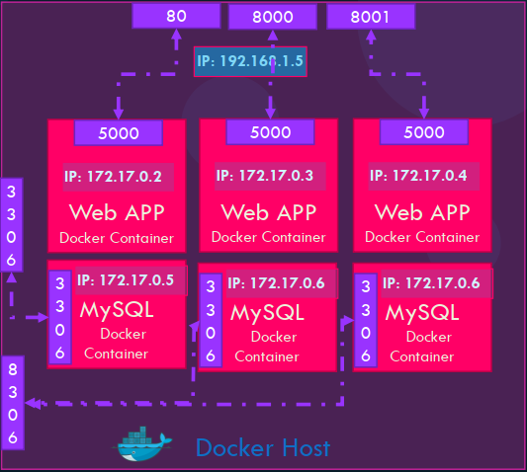

192.168.0.3

Port is already allocated

github.com/kunchalavikram1427

# A close up of a sign Description automatically generatedDocker Networking: Host

* In host network, all containers directly get connected to

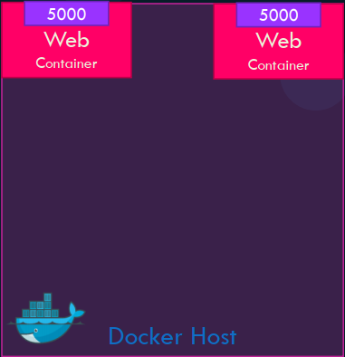

80

80

host.

* Multiple containers cannot run on same hosts because of port conflicts on host side

### docker run -d --name web -net host nginx

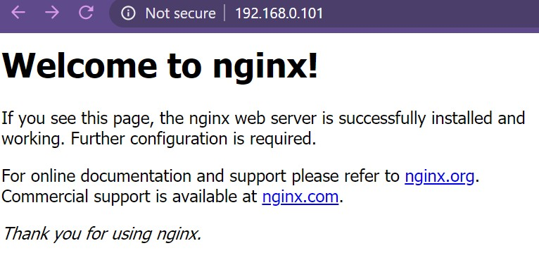192.168.0.101

github.com/kunchalavikram1427

# Docker Networking: None

github.com/kunchalavikram1427

* 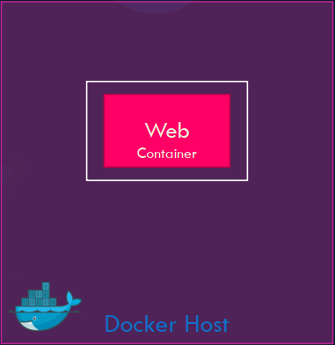This offers a container-specific network stack that lacks a

network interface.

* Containers run in pure isolation
* This container only has a local loopback interface (i.e., no external network interface)

### docker run -d --name web --net none nginx

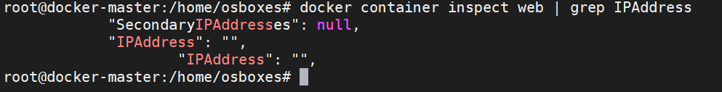github.com/kunchalavikram1427

# A close up of a sign Description automatically generatedDocker Networking: Overlay

### Bridge networks apply to containers running on the same Docker daemon host. For communication among containers running on different Docker daemon hosts, we should use an overlay network which spans across the entire cluster

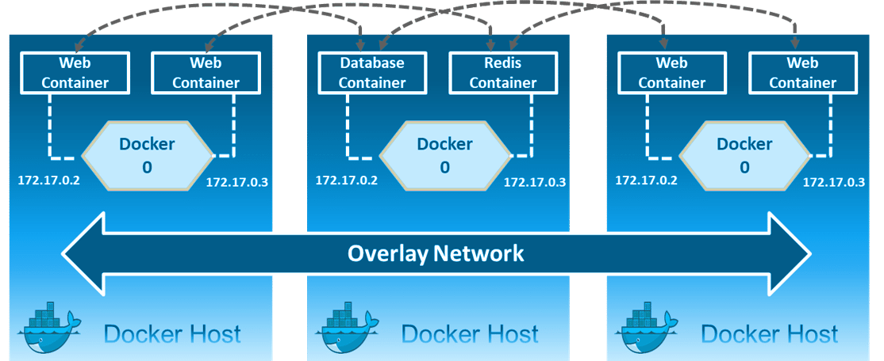github.com/kunchalavikram1427

# Docker Volumes

github.com/kunchalavikram1427

* + Images are a series of read-only layers
  + A container is merely an instantiation of those read-only layers with a single read-write layer on top.
  + Any file changes that are made within a container are reflected as a copy of modified data from the read-only layer.
  + The version in the read-write layer hides the underlying file but does not remove it.
  + When deleting a container, the read-write layer containing the changes are destroyed and gone forever!
  + In order to persist these changes we use docker volumes Advantages:

1. To keep data around when a container is removed
2. To share data between the host filesystem and the Docker container

github.com/kunchalavikram1427

# Docker Volumes

github.com/kunchalavikram1427

### A close up of a sign Description automatically generatedTwo types of volume mounts: Named and Bind

Named Volume: Mounting a volume created using ‘docker volume create’ command and mounting it from default volume location /var/lib/docker/volumes docker volume create my-vol

### docker run -d --name nginx -v myvol:/app nginx

docker run -d --name nginx --mount source=myvol2,target=/app nginx



/app

Container

Docker host

/var/lib/docker/volumes/myvol

github.com/kunchalavikram1427

# Docker Volumes

github.com/kunchalavikram1427

Two types of volume mounts: **Named** and **Bind**

### Bind Volume: External mounting(external hard disks etc.)

Bind mounts may be stored anywhere on the host system. They usually start with

### ‘/’

docker run –name web -v /root/html:/var/www/html/ nginx



/var/www/html

Container

Docker host

/root/html

github.com/kunchalavikram1427

# A close up of a sign Description automatically generatedDocker volumes commands

### docker volume create <volume_name> docker volume ls

docker volume inspect <volume_name> docker volume rm <volume_name> docker volume prune

Named Volume Bind Volume

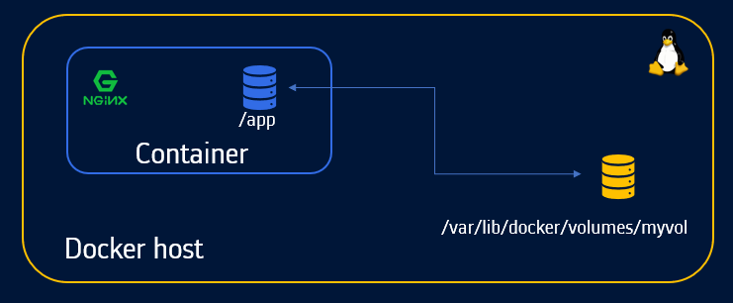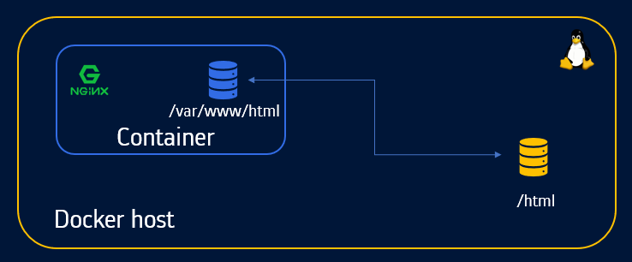

github.com/kunchalavikram1427

# Docker Volumes

github.com/kunchalavikram1427

### A close up of a sign Description automatically generatedDemo: Hosting a static website using nginx docker run -d --name web –p 80:80 nginx

docker exec -it web bash

root@768faf801706:/# ls /usr/share/nginx/html 50x.html **index.html**

docker run -d --name web -p 80:80 -v $PWD:/usr/share/nginx/html nginx





/usr/share/nginx/html

Container

Docker host

$PWD/index.html

github.com/kunchalavikram1427

# Building Images

github.com/kunchalavikram1427

* Hosting a static website was easier as base image nginx has all dependencies to host.
* What if we are required to host an application which requires lot of dependencies which base image do not provide? We build the image!!!

Let’s say a flask application has to be built docker run –it --name my-app ubuntu bash root@beb164a51e6a:/# apt update



apt update

apt install python

pip install flask

app.py

root@beb164a51e6a:/# apt install python

root@beb164a51e6a:/# pip install flask root@beb164a51e6a:/# exit

docker commit my-app my-flask-app

container-name image-name

github.com/kunchalavikram1427

# Dockerfile

github.com/kunchalavikram1427

### A close up of a sign Description automatically generated• Dockerfile is essentially the build instructions to build your image

• It is a text document that contains all the commands a user could call on the command line to assemble the image

### • Using docker build users can create an automated build that executes several command-line instructions in succession

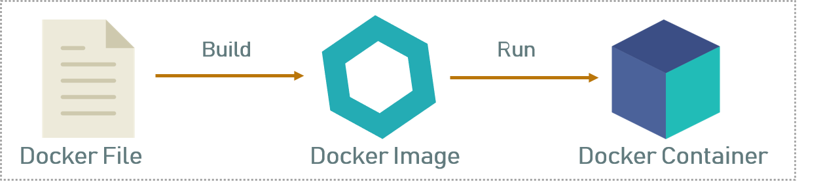

Name of the file is Dockerfile without any extensions

github.com/kunchalavikram1427

# Dockerfile contents

github.com/kunchalavikram1427

• FROM defines the base image used to start the build process

• MAINTAINER defines a full name and email address of the image creator

• COPY copies one or more files from the Docker host into the Docker image

• EXPOSE exposes a specific port to enable networking between the container and the outside world

• RUN runs commands while image is being built from the dockerfile and saves result as a new layer

• VOLUME is used to enable access from the container to a directory on the host machine

• WORKDIR used to set default working directory for the container

• CMD command that runs when the container starts

• ENTRYPOINT command that runs when the container starts

<http://tutorials.jenkov.com/docker/dockerfile.html>

github.com/kunchalavikram1427

# Dockerfile

github.com/kunchalavikram1427

flask_app

Dockerfile app.py

FROM python:alpine3.7 COPY . /app

WORKDIR /app RUN pip install flask EXPOSE 5000

CMD python ./app.py

FROM ubuntu

RUN apt-get update



### (or)

RUN apt-get install -y python python-pip wget RUN pip install Flask

COPY app.py /home/app.py

WORKDIR /home

Build the image:

docker build -t flaskapp .

(make sure you are in the directory of docker file and Dockerfile has no name extensions)

-t – Tag the image with a name

. – Dot indicates look for Dockerfile from PWD/Present Working Directory

CMD python app.py

Source: [https://github.com/kunchalavikram1427/Docker_public/tree/ master/Examples/Dockerfile-flask](https://github.com/kunchalavikram1427/Docker_public/tree/master/Examples/Dockerfile-flask)

github.com/kunchalavikram1427

# Dockerfile

docker images

github.com/kunchalavikram1427

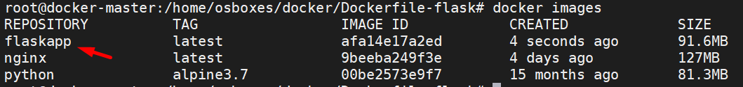



docker run -d --name flask -p 80:5000 flaskapp



Flask listens on port 5000 by default. You can also configure it to a different port

FROM python:alpine3.7

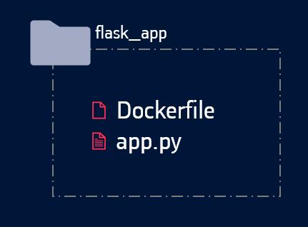COPY . /app WORKDIR /app RUN pip install flask EXPOSE 5000

CMD python ./app.py

github.com/kunchalavikram1427

# Dockerfile

github.com/kunchalavikram1427

flask_app

Dockerfile appv3.py static/image.jpg

templates/index.html

Demo: Building a single landing page dynamic website using flask

import socket

from flask import Flask,request, render_template

FROM python:alpine3.7 COPY . /app

WORKDIR /app RUN pip install flask EXPOSE 5000

CMD python ./appv3.py

appv3.py

Dockerfile

Source: [https://github.com/kunchalavikram1 427/Docker_public/tree/master/Exa mples/Dockerfile-flask-example](https://github.com/kunchalavikram1427/Docker_public/tree/master/Examples/Dockerfile-flask-example)

def getIP():

hostname = socket.gethostname()

s = socket.socket(socket.AF_INET, socket.SOCK_DGRAM) s.connect(("8.8.8.8", 80))

ip = s.getsockname()[0] print(ip)

s.close()

return str(hostname),str(ip) app = Flask( name ) @app.route("/")

def hello():

hostname,ip = getIP()

return render_template('index.html',hostname=hostname,ip=ip)

if name == " main ":

app.run(host="0.0.0.0", port=int("5000"), debug=True)

index.html file should in templates directory and image should be in static directory

We will pass these variables to index.html file

github.com/kunchalavikram1427

# Dockerfile

github.com/kunchalavikram1427

Demo: Building a single landing page dynamic website using flask

Build Image and Push to docker hub docker build –t <username>/flask-app . docker push <username>/flask-app

<username> - Your docker hub account name

Run the container

docker run -d --name flaskapp -p 80:5000 <user- name>/flask-app

<!DOCTYPE html>

<html>

index.html

<title>Smart City</title>

<meta charset="UTF-8">

<meta name="viewport" content="width=device-width, initial-scale=1">

<link rel="stylesheet" href="https://[www.w3schools.com/w3css/4/w3.css](http://www.w3schools.com/w3css/4/w3.css)">

<link rel="stylesheet" href="https://fonts.googleapis.com/css?family=Raleway">

<style>

body,h1 {font-family: "Raleway", sans-serif} body, html {height: 100%}

.bgimg {

background-image: url('/static/smartcity.jpg'); min-height: 100%;

background-position: center; background-size: cover;

}

</style>

<body>

<div class="bgimg w3-display-container w3-animate-opacity w3-text-white">

<div class="w3-display-topleft w3-padding-large w3-xlarge">

Connected City

</div>

<div class="w3-display-middle">

<h1 class="w3-jumbo w3-animate-top" style="text-align:center"> Connected City </h1>

<hr class="w3-border-grey" style="margin:auto;width:40%">

<p class="w3-large w3-center"> Website processed by container: {{ hostname }} with IP: {{ ip }} </p>

</div>

<div class="w3-display-bottomleft w3-padding-large">

Powered by <a href="https://github.com/kunchalavikram1427" target="_blank">Github</a>

</div>

</div>

</body>



192.168.0.2

</html>

github.com/kunchalavikram1427

# Docker Compose

github.com/kunchalavikram1427

• Docker Compose is used to run multiple containers as a single service.

• For example, an application requires both NGNIX and MySQL containers, you could create one file which would start both the containers as a service(docker compose) or start each one separately(docker run)

• All services are to be defined in YAML format

compose file: docker-compose.yml



3306

back-end

172.17.0.3

front-end

172.17.0.2

Docker host/VM

8080

80

Bring up the app: docker-compose up –d Bring down the app: docker-compose down

192.168.0.3

<https://takacsmark.com/docker-compose-tutorial-beginners-by-example-basics/>

github.com/kunchalavikram1427

# A close up of a sign Description automatically generatedDocker Compose

### Compose file syntax

version: '3' # if no version is specified then v1 is assumed.

services: # containers. same as docker run

service_name: # container name. this is also DNS name inside network image: # name of the image

command: # Optional, replace the default CMD specified by the image

environment: # same as -e in docker run ports: # same as –p in docker run volumes: # same as -v in docker run



3306

80

back-end

172.17.0.3

front-end

172.17.0.2

Docker host/VM

8080

service_name2:

volumes: # Optional, same as docker volume create

networks: # Optional, same as docker network create

192.168.0.3

github.com/kunchalavikram1427

# A close up of a sign Description automatically generatedDocker Compose versions

Version 1

* Compose files that do not declare a version are considered “version 1”
* Do not support named volumes, user-defined networks or build arguments
* Every container is placed on the default bridge network and is reachable from every other container

at its IP address. You need to use links to enable discovery between containers

* No DNS resolution using container names

Version 2

* Links are deprecated. DNS resolution through container names
* All services must be declared under the ‘services’ key
* Named volumes can be declared under the volumes key, and networks can be declared under the networks key
* New bridge network to connect all containers

Version 3

* + Support for docker swarm

github.com/kunchalavikram1427

# A close up of a sign Description automatically generatedDocker Compose

wordpress:

image: wordpress depends_on:

* mysql ports:

- 8080:80

environment: WORDPRESS_DB_HOST: mysql WORDPRESS_DB_NAME: wordpress WORDPRESS_DB_USER: wordpress

WORDPRESS_DB_PASSWORD: wordpress

volumes:

* ./wordpress-data:/var/www/html networks:
* my_net

version: '3.3' services:

wordpress:

image: wordpress depends_on:

* mysql ports:

- 8080:80

environment: WORDPRESS_DB_HOST: mysql WORDPRESS_DB_NAME: wordpress WORDPRESS_DB_USER: wordpress

WORDPRESS_DB_PASSWORD: wordpress volumes:

* ./wordpress-data:/var/www/html networks:
* my_net mysql:

image: mariadb environment:

MYSQL_ROOT_PASSWORD: wordpress MYSQL_DATABASE: wordpress MYSQL_USER: wordpress MYSQL_PASSWORD: wordpress volumes:

* mysql-data:/var/lib/mysql networks:
* my_net volumes: mysql-data: networks: my_net:

mysql:

image: mariadb environment:

MYSQL_ROOT_PASSWORD: wordpress MYSQL_DATABASE: wordpress MYSQL_USER: wordpress MYSQL_PASSWORD: wordpress volumes:

* mysql-data:/var/lib/mysql networks:
* my_net

github.com/kunchalavikram1427



80

Docker host/VM

8080

3306

volumes: mysql-data: networks: my_net:

# Docker Compose

version: '3.3' services:

wordpress:

image: wordpress depends_on:

* mysql ports:

- 8080:80

environment: WORDPRESS_DB_HOST: mysql WORDPRESS_DB_NAME: wordpress WORDPRESS_DB_USER: wordpress

WORDPRESS_DB_PASSWORD: wordpress volumes:

* ./wordpress-data:/var/www/html networks:
* my_net mysql:

image: mariadb environment:

MYSQL_ROOT_PASSWORD: wordpress MYSQL_DATABASE: wordpress MYSQL_USER: wordpress MYSQL_PASSWORD: wordpress volumes:

* mysql-data:/var/lib/mysql networks:
* my_net volumes: mysql-data: networks: my_net:

github.com/kunchalavikram1427

Services file: docker-compose.yml Bring up: docker-compose up –d



80

Docker host/VM

8080

3306

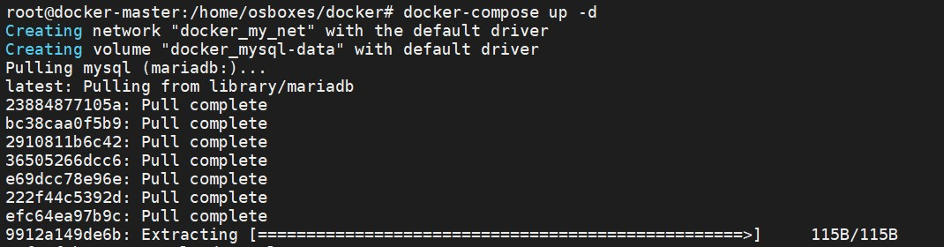Bring down: docker-compose down Process state: docker-compose ps



github.com/kunchalavikram1427

# Docker Compose

github.com/kunchalavikram1427



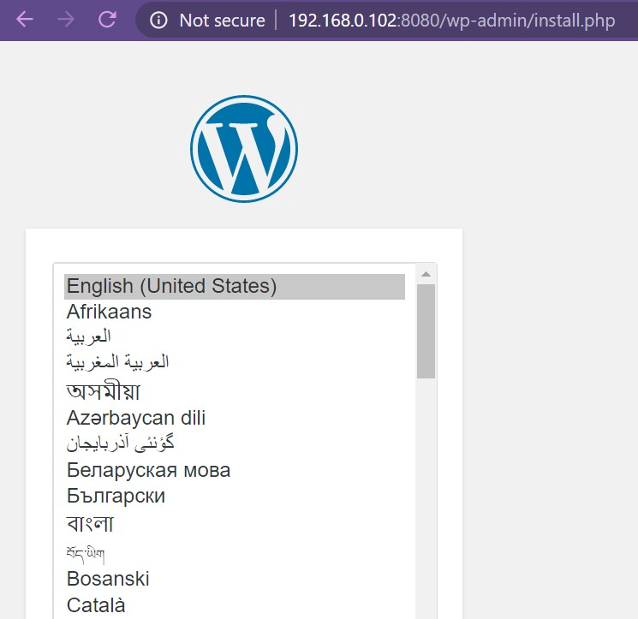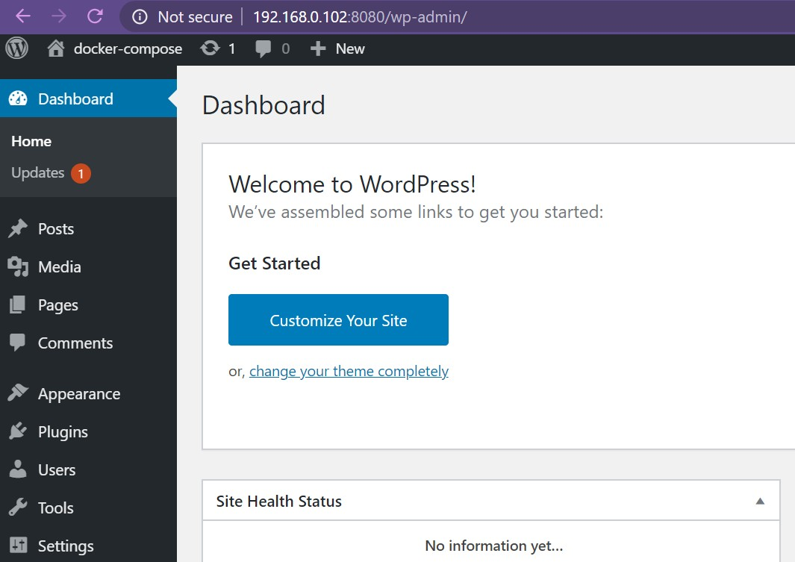0



33

06

8

0

Docker host/VM

808

github.com/kunchalavikram1427

# Docker Compose

Image build

version: '3.3'

services:

wordpress:

image: wordpress depends_on:

* mysql ports:

- 8080:80

environment: WORDPRESS_DB_HOST: mysql WORDPRESS_DB_NAME: wordpress WORDPRESS_DB_USER: wordpress

WORDPRESS_DB_PASSWORD: wordpress volumes:

* ./wordpress-data:/var/www/html networks:
* my_net

mysql:

image: mariadb environment:

MYSQL_ROOT_PASSWORD: wordpress MYSQL_DATABASE: wordpress MYSQL_USER: wordpress MYSQL_PASSWORD: wordpress volumes:

* mysql-data:/var/lib/mysql

networks:

* my_net volumes: mysql-data: networks: my_net:

github.com/kunchalavikram1427

If the image has to be built before deployment, include dockerfile in compose file

version: "3" services:

wordpress: build:

context: .

dockerfile: Dockerfile-wordpress image: wordpress container_name: wordpress

webapp

docker-compose.yml

Dockerfile-wordpress



To build only images: docker-compose build



80

Docker host/VM

3306

8080

build + deploy: docker-compose up -d

github.com/kunchalavikram1427

# Docker Compose

version: '3.3' services:

wordpress:

image: wordpress depends_on:

* mysql ports:

- 8080:80

environment: WORDPRESS_DB_HOST: mysql WORDPRESS_DB_NAME: wordpress WORDPRESS_DB_USER: wordpress

WORDPRESS_DB_PASSWORD: wordpress volumes:

* ./wordpress-data:/var/www/html networks:
* my_net mysql:

image: mariadb environment:

MYSQL_ROOT_PASSWORD: wordpress MYSQL_DATABASE: wordpress MYSQL_USER: wordpress MYSQL_PASSWORD: wordpress volumes:

* mysql-data:/var/lib/mysql networks:
* my_net volumes: mysql-data: networks: my_net:

github.com/kunchalavikram1427

Deployment through imperative commands

docker network create –driver bridge my_net docker volume create mysql-data

docker run --name wordpress –p 8080:80 –v ./wordpress-data:/var/www/html \

–net my_net –e WORDPRESS_DB_HOST = mysql \

-e WORDPRESS_DB_NAME: wordpress \

-e WORDPRESS_DB_USER: wordpress \

-e WORDPRESS_DB_PASSWORD: wordpress \

wordpress

docker run --name wordpress –p 3306 –v mysql-data:/var/lib/mysql –net my_net

-e MYSQL_ROOT_PASSWORD: wordpress \

-e MYSQL_DATABASE: wordpress \

-e MYSQL_USER: wordpress \



80

Docker host/VM

8080

3306

-e MYSQL_PASSWORD: wordpress \ mariadb

github.com/kunchalavikram1427



NEXT

Docker Swarm

github.com/kunchalavikram1427



Docker

**Swarm**

#### Vikram

IoT Application Dev

github.com/kunchalavikram1427

github.com/kunchalavikram1427

# Container Orchestration

* Containers are ephemeral by nature.
* They stop when process inside them finishes, or ends because of an error.
* Also a single container per service may not be sufficient enough to handle the growing traffic to the application.
* In all the above scenarios we need a tool that can bring up the stopped containers or spin up new one’s to handle the growing traffic and to ensure Load balancing & High availability of the application all the time.
* This is where container orchestration comes into play!!!

What is container orchestration?

Container orchestration is all about managing the lifecycles of containers, especially in large, dynamic

environments.

* Provisioning and deployment of containers
* Scaling up or removing containers to spread application load evenly across host infrastructure
* Movement of containers from one host to another if there is a shortage of resources in a host, or if a

host dies

* Load balancing of service discovery between containers

github.com/kunchalavikram1427

# Docker Swarm

github.com/kunchalavikram1427

* Swarm is Docker’s built in container orchestrator solution, its main purpose is to manage

containers in a cluster, i.e. a set of connected machines that work together.

* When a new machine joins the cluster, it becomes a node in that swarm.
* Using Docker Swarm we can achieve high availability, load balancing and Decentralized access of our applications.
* Swarm comes built into the Docker Engine, you don’t need to install anything to get started.

What can one do by using Docker Swarm?



* Deploying new containers to replace failed ones
* Scale the number of containers for load balancing
* Rolling out application updates among the containers in rolling update fashion
* Rollback of applications to older versions
* Bring down a node for maintenance without any application downtime

github.com/kunchalavikram1427

# Docker Swarm Architecture

github.com/kunchalavikram1427

* Manager: manages the cluster

Docker client

* Worker: runs tasks assigned by scheduler
* Scheduler: schedules containers onto nodes depending upon rules and filters
* Discovery service: helps Swarm Manager discover new nodes and fetch the available nodes
* Store: stores state of cluster; like cluster and swarm services info. Essentially a key-value db

APIs over HTTP

Docker Daemon

Swarm worker

192.168.0.4 192.168.0.5

192.168.0.3

Store

Swarm Manager

Scheduler

Discovery

Service

APIs over HTTP

Docker Daemon

Swarm worker

 -- container github.com/kunchalavikram1427

github.com/kunchalavikram1427

# Docker Swarm: Overlay driver

* + Bridge networks apply to containers running on the same Docker daemon host. For communication among containers running on different Docker daemon hosts like in swarm, we should use an overlay network
  + If you create swarm services and do not specify a network, they are connected to default ingress network, which is also of overlay type
  + Overlay network spans across the entire swarm cluster, allowing communication between containers across multiple nodes

docker network ls

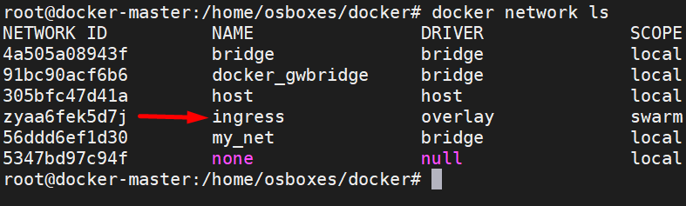

<https://docs.docker.com/engine/swarm/ingress/>

github.com/kunchalavikram1427

github.com/kunchalavikram1427

# Docker Swarm: Start a cluster

### docker swarm init --advertise-addr MANAGER_IP

root@docker-master # docker swarm init --advertise-addr 192.168.0.100

Swarm initialized: current node (pet61mspmyfvk6lz0klisd9e9) is now a manager. To add a worker to this swarm, run the following command:

master node

docker swarm join --token SWMTKN-1-3kabuqlekspyqdk02vj0strami9mcysj8lw4klp5cwmh3wm4ej- 9rlom6m90chce1tgi0ke58t4l 192.168.0.100:2377

To add a manager to this swarm, run 'docker swarm join-token manager' and follow the instructions.

root@docker-slave01 # docker swarm join --token SWMTKN-1-

3kabuqlekspyqdk02vj0strami9mcysj8lw4klp5cwmh3wm4ej-9rlom6m90chce1tgi0ke58t4l 192.168.0.100:2377

This node joined a swarm as a worker.

root@docker-slave01:/home/osboxes#

worker node

github.com/kunchalavikram1427

# Docker Swarm

github.com/kunchalavikram1427

### A close up of a sign Description automatically generateddocker node ls

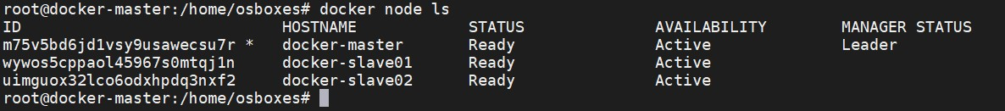



80

80

80

front-end

front-end

front-end

Docker master

8080

Docker worker 1

8080

Docker worker 2

8080

overlay driver

192.168.0.100

192.168.0.101

192.168.0.102

root@docker-master # docker network ls | grep overlay qh17ylskxm31 ingress overlay swarm

github.com/kunchalavikram1427

# Docker Service

github.com/kunchalavikram1427

* + To deploy an application image when Docker Engine is in swarm mode, you create a service.
  + A service is the image for a microservice like an HTTP server, a database, or any other type of executable program that you wish to run in a distributed environment.
  + A service needs container image to use, the port where the swarm makes the service available outside the swarm, an overlay network for the service to connect to other services in the swarm and the number of replicas of the image to run in the swarm.

### Create a service

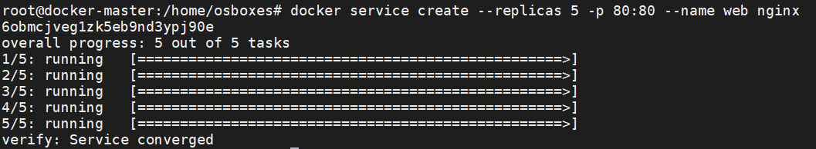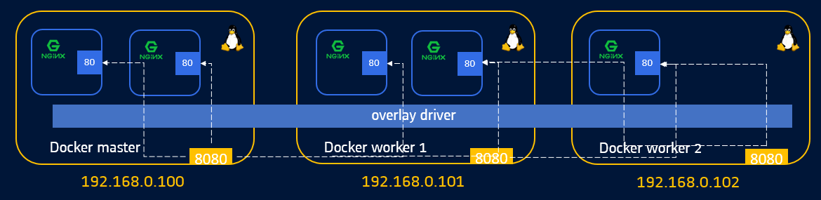docker service create --replicas 5 -p 80:80 --name web nginx

github.com/kunchalavikram1427

# Docker Service

### docker service ls

github.com/kunchalavikram1427





80

80

80

80

80

overlay driver

Docker master

8080

Docker worker 1

8080

Docker worker 2

8080

192.168.0.100

192.168.0.101

192.168.0.102



github.com/kunchalavikram1427

github.com/kunchalavikram1427

# Docker Swarm Visualizer

### Deploy a visualizer

docker service create \

--name=viz \

--publish=8080:8080/tcp \

--constraint=node.role==manager \

--mount=type=bind,src=/var/run/docker.sock,dst=/var/run/docker.sock \

dockersamples/visualizer

Dashboard available at http://<node-ip>:8080

*node-ip: any IP of node participating in cluster

*although the pod is bound to master, it can be reached from all nodes because of ingress routing mesh

https://github.com/dockersamples/docker-swarm-visualizer

github.com/kunchalavikram1427

github.com/kunchalavikram1427

# Docker Service

Name of the

service

### docker service ps web

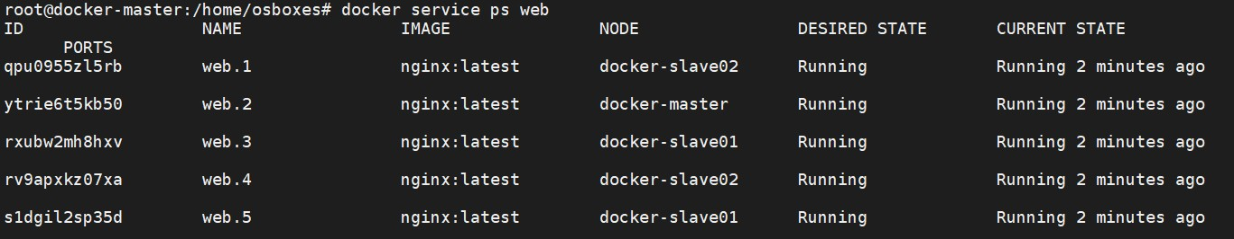

docker node ps docker-slave01

Name of the node

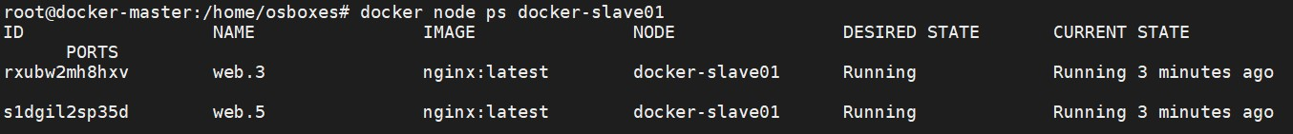

github.com/kunchalavikram1427

# Docker Service

github.com/kunchalavikram1427

### A close up of a sign Description automatically generateddocker service ps web

Master Slave -01 Slave -02 docker service create --replicas 5 -p 80:80 --name web nginx

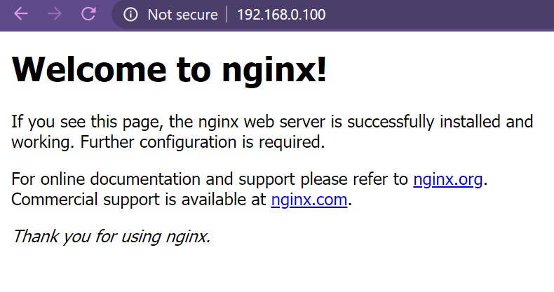

192.168.0.100



192.168.0.101



192.168.0.104

github.com/kunchalavikram1427

# Docker Service

github.com/kunchalavikram1427

### A close up of a sign Description automatically generatedScale a service

docker service scale <service_name>=8 docker service scale web=10

### Update a service

docker service update --image <image_name>:<version> <service_name> docker service update --image nginx:1.18 web

### Rolling update

docker service update –image <new_image> --update-parallelism 2 --update-delay 10s

<service_name>

docker service update --image nginx:1.18 --update-parallelism 2 --update-delay 10s web

github.com/kunchalavikram1427

# Docker Service

github.com/kunchalavikram1427

### A close up of a sign Description automatically generatedLet’s say, a node is down because of an issue

In this case the affected containers in that node are recreated in available nodes in the cluster

docker service ls



docker service ps web

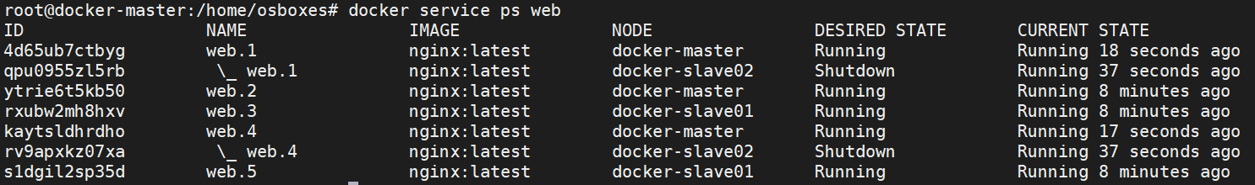

github.com/kunchalavikram1427

# Docker Service

github.com/kunchalavikram1427

* + Let’s say, a node has to be brought down for maintenance

In this case we drain a node of its workloads onto other nodes for graceful termination

Drain a node: docker node update --availability drain <node-name> Undrain a node: docker node update --availability active <node-name>

* + Let’s say, the node is up and running after maintenance

By default, swarm doesn’t re-deploy the containers the node was previously running. We

need to force the cluster to share the load among the available nodes Force workload balance: docker service update --force <service_name>

Rollback an update: docker service update --rollback <service_name> Remove a service: docker service rm <service_name>

github.com/kunchalavikram1427

# Docker Swarm: Overlay driver

Creating overlay network

docker network create --driver overlay my_overlay

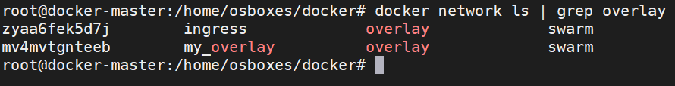

docker service create --replicas 5 -p 80:80 --network my_overlay --name web nginx Inspecting the service:

docker service inspect web

<https://docs.docker.com/engine/swarm/ingress/>

github.com/kunchalavikram1427

github.com/kunchalavikram1427

# Docker Service

import socket

from flask import Flask

def getIP():

hostname = socket.gethostname()

s = socket.socket(socket.AF_INET, socket.SOCK_DGRAM) s.connect(("8.8.8.8", 80))

ip = s.getsockname()[0] print(ip)

s.close()

return hostname,ip

app = Flask( name )

@app.route("/")

def hello():

hostname,ip = getIP()

out = "Hello from hostname: " + hostname + " with host ip: " + ip return out

if name == " main ":

app.run(host="0.0.0.0", port=int("5000"), debug=True)

app.py

Demo: Swarm service

Dockerfile

docker build –t <username>/flask-app . docker push <username>/flask-app

FROM python:alpine3.7 COPY . /app

WORKDIR /app RUN pip install flask EXPOSE 5000

CMD python ./app.py

In order to use a custom image in swarm cluster, make sure to push this image to docker hub or private repo so that the swarm nodes will pull the image, or, make sure this image is available locally on all nodes by manually building the image from dockerfile. Swarm will not schedule containers

on to those nodes which fail to pull the image or do not have this image locally!

github.com/kunchalavikram1427

github.com/kunchalavikram1427

# Docker Service

Demo: Swarm service

docker service create --replicas 5 -p 80:5000 --name web kunchalavikram/sampleflask:v2

visit

http://<node-ip>:80 and refresh the page to see the load balancing effect

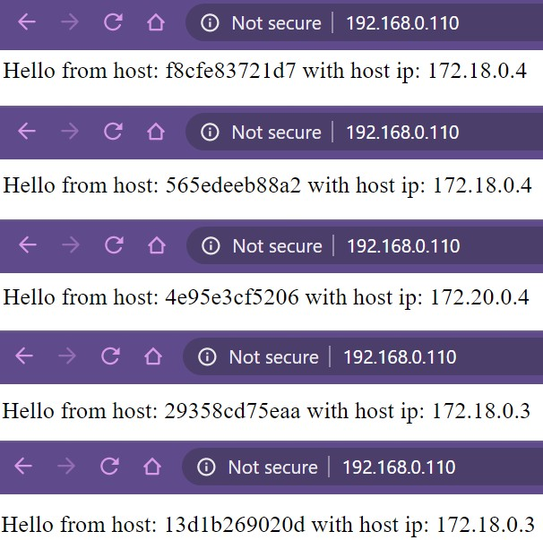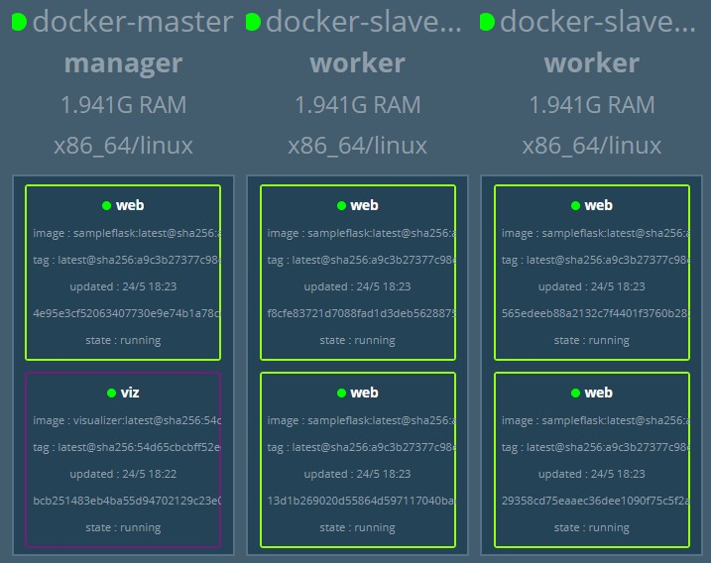github.com/kunchalavikram1427

github.com/kunchalavikram1427

# Docker Service

Demo: Swarm service

Find similar swarm load-balancing demo at below link

<https://levelup.gitconnected.com/load-balance-and-scale-node-js-containers-with-nginx-and-docker-swarm-9fc97c3cff81>

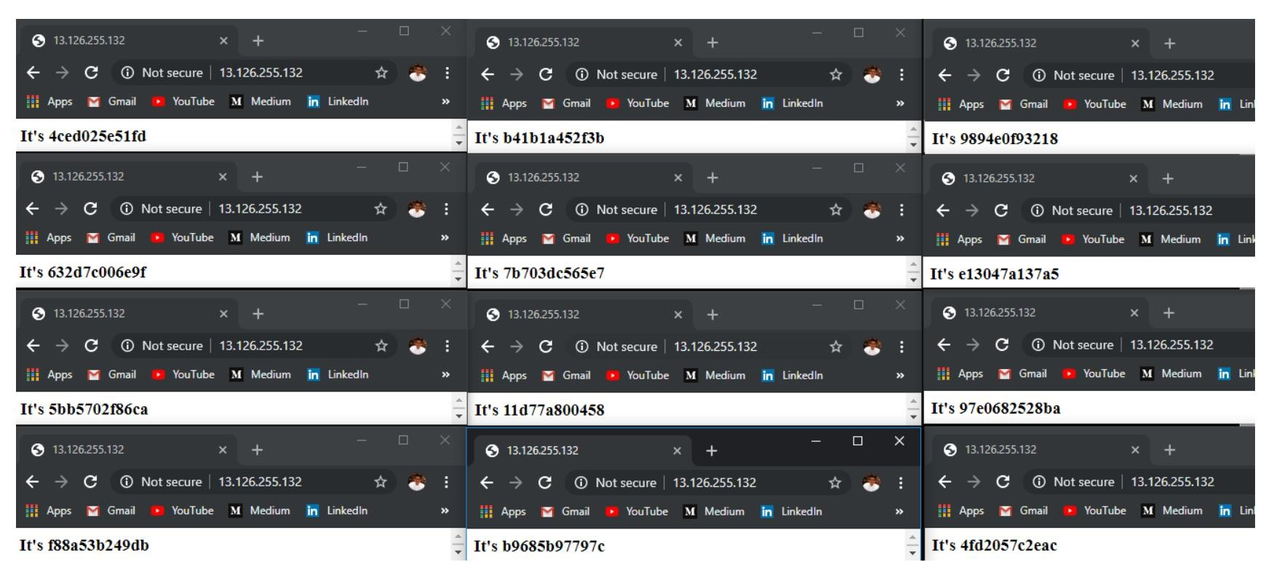

github.com/kunchalavikram1427

# Docker Networking

### Ingress Network

github.com/kunchalavikram1427





192.168.0.24:80

Is it possible to run 2 containers with same host port published in non swarm mode?



80

5000

5000

172.17.0.4

172.17.0.5

Docker host

Flask Webapp

Flask

Webapp

docker run –d –p 80:5000 --name web1 flask docker run –d –p 80:5000 --name web2 flask

No!!! It results in port conflict. Docker daemon doesn’t allow

same host port for multiple containers in non swarm mode

Then how does docker allow running multiple instances of same application(with same host port mapping) in a node inside a swarm cluster?

docker service create --replicas 5 -p 80:5000 --name web flask

192.168.0.24

github.com/kunchalavikram1427

Ingress Routing Mesh

# Docker Networking

### Ingress Network

github.com/kunchalavikram1427





192.168.0.24:80

* + - Ingress network has a built in load balancer that redirects traffic from published port on host to the mapped container ports



80

Load Balancer

Ingress Network

5000

5000

172.17.0.4

172.17.0.5

Docker host

Flask Webapp

Flask Webapp

* + - This allows multiple containers inside a docker host to use same host port without port collisions
    - No external setup is needed, the load balancer works out of the box with the ingress network

### docker service create --replicas 5 -p 80:5000 --name web flask

192.168.0.24

github.com/kunchalavikram1427

# Docker Networking

github.com/kunchalavikram1427

Ingress Routing Mesh docker service create --replicas 2 -p 80:5000 --name web flask



192.168.0.24:80



80

192.168.0.25:80

80

192.168.0.26:80

80

Load Balancer

#### Routing Mesh

Load Balancer

#### Routing Mesh

Load Balancer

Ingress Network

5000 5000

Flask Webapp

Flask Webapp

172.17.0.4 172.17.1.2

Docker Master

192.168.0.24

Docker Worker

192.168.0.25

Docker Worker

192.168.0.26

github.com/kunchalavikram1427

github.com/kunchalavikram1427

# Docker Networking

### Ingress Routing Mesh

The swarm internal networking mesh allows every node in the cluster to accept connections to any service port published in the swarm by routing all incoming requests to available nodes hosting a service with the published port.

docker service create --replicas 2 -p 80:5000 --name web flask

github.com/kunchalavikram1427

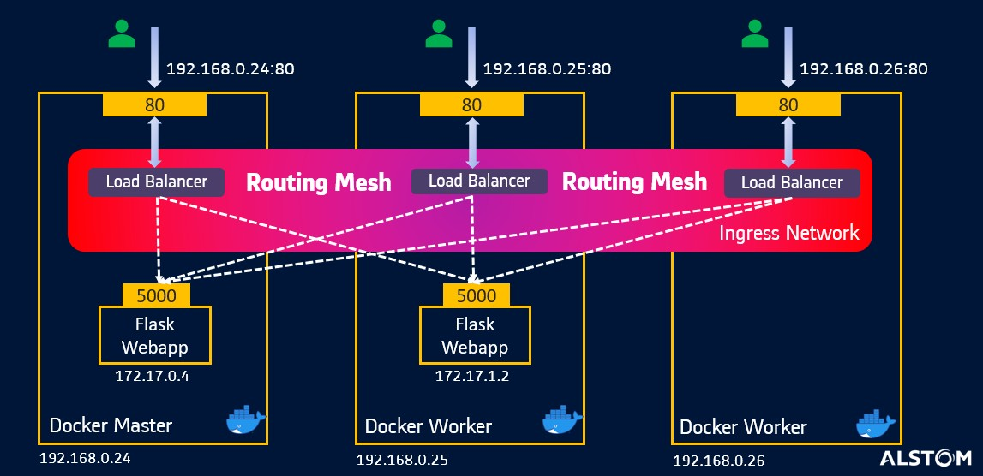

Docker Service

### A screenshot of a cell phone Description automatically generatedIngress Routing Mesh

* + - 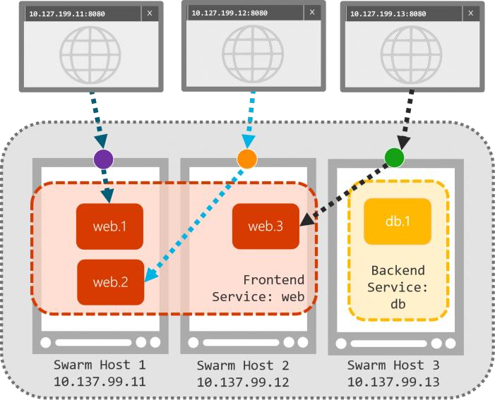All nodes participate in an **ingress routing mesh**. The routing mesh enables each node in the swarm to accept connections on published ports for any service running in the swarm, even if there’s no task running on the node.
    - The routing mesh routes all incoming requests to published ports on available nodes to an active container.
    - In this scenario, we have 3 nodes and 4 replicas of web containers. The web containers are scheduled onto only Host 1 and Host 2. But still we can reach the web services from Host 3 because of swarm routing mesh

<https://docs.docker.com/network/network-tutorial-overlay/> <https://docs.docker.com/engine/swarm/ingress/>

github.com/kunchalavikram1427

Docker Service

### Load Balancer (ingress routing mesh)

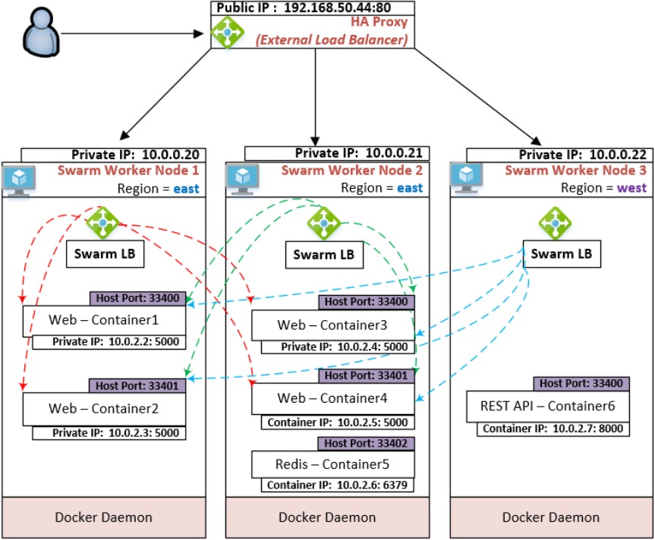

The ingress network is a special overlay network that facilitates load balancing among a service's nodes. When any swarm node receives a request on a published port, it hands that request off to a

module called IPVS. IPVS keeps track of all the IP addresses participating in that service, selects one of them, and routes the request to it, over the ingress network. github.com/kunchalavikram1427

github.com/kunchalavikram1427

# Docker Swarm

Persistent Storage

* + - Persistent storage is storing the data of the container beyond its lifecycle.
    - For single host containers, Bind or Named mounts works fine, but in order to share storage volumes across multiple Docker hosts, such as a Swarm cluster, we need distributed FS or Network FS.

Use of Distributed/Network FS

* Because programs running on your cluster aren’t guaranteed to run on a specific node, data can’t be saved to any arbitrary place in the file system.
* If a program tries to save data to a file for later, but is then relocated onto a new node, the file will no longer be where the program expects it to be.
* Distributed/Network FS allows applications to have a common storage volume to store and retrieve the data beyond its lifecycle.

<https://theworkaround.com/2019/05/15/docker-swarm-persistent-storage.html>

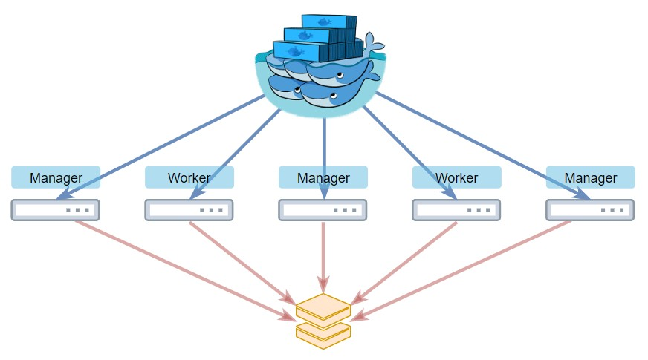

github.com/kunchalavikram1427

# Docker Swarm

Persistent Storage in single node

* + - Named Mount
    - Bind Mount

github.com/kunchalavikram1427

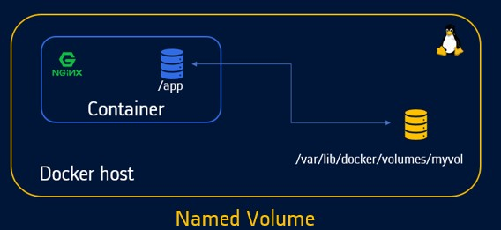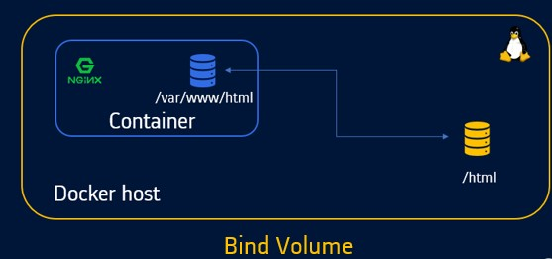

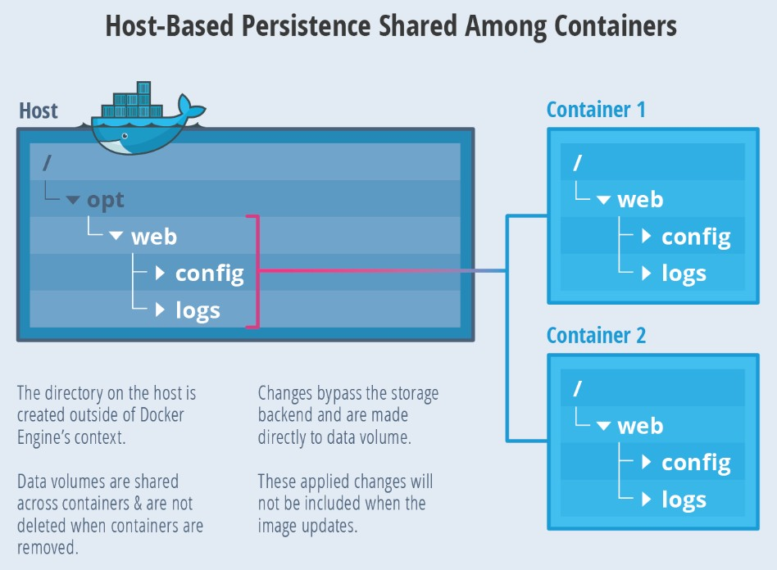<https://thenewstack.io/methods-dealing-container-storage/>

github.com/kunchalavikram1427

# A close up of a sign Description automatically generatedDocker Swarm

Persistent Storage across cluster

Requires distributed/network file storage

* + - 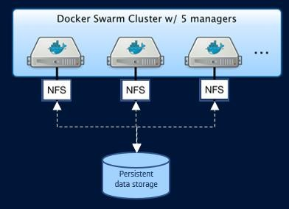NFS
    - GlusterFS
    - Ceph
    - Convoy
    - RexRay
    - PortWorx
    - 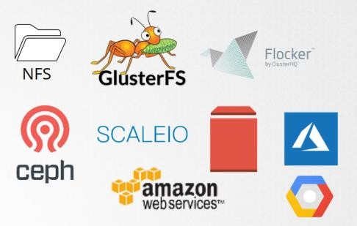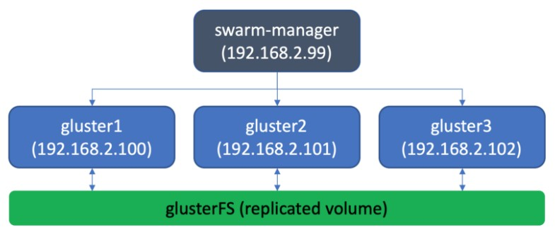StorageOS

<https://theworkaround.com/2019/05/15/docker-swarm-persistent-storage.html>

GlusterFS

github.com/kunchalavikram1427

# Docker Stacks

github.com/kunchalavikram1427

* Docker stack is used to deploy a complete application stack to the swarm.
* Production grade docker-compose
* Docker-compose is better suited for development scenarios and is a single host deployment solution
* Uses the same syntax as docker-compose file, but with a new section ‘deploy’ added

to manifest file

* Docker stack ignores “build” instructions. You can’t build new images using the stack

commands. It needs pre-built images to exist



3306

80

back-end

front-end

back-end

front-end

back-end

front-end

Docker master

80

Docker worker 1

80

Docker worker 2 80

overlay driver

3306

80

3306

80

192.168.0.100

192.168.0.101

github.com/kunchalavikram1427

192.168.0.102

# Docker Stack

version: '3.3' services:

wordpress:

image: wordpress depends_on:

* mysql ports:

- 80:80

deploy:

replicas: 2 placement:

constraints:

- node.role == manager environment: WORDPRESS_DB_HOST: mysql WORDPRESS_DB_NAME: wordpress WORDPRESS_DB_USER: wordpress

WORDPRESS_DB_PASSWORD: wordpress

volumes:

* wordpress-data:/var/www/html networks:
* my_net mysql:

image: mariadb deploy:

replicas: 1 placement:

constraints:

* + node.role == worker environment:

MYSQL_ROOT_PASSWORD: wordpress MYSQL_DATABASE: wordpress MYSQL_USER: wordpress MYSQL_PASSWORD: wordpress volumes:

* mysql-data:/var/lib/mysql networks:
* my_net networks: my_net: volumes: mysql-data:

wordpress-data:

github.com/kunchalavikram1427



mysql:

image: mariadb deploy:

replicas: 1 placement:

constraints:

- node.role == worker environment:

MYSQL_ROOT_PASSWORD: wordpress MYSQL_DATABASE: wordpress MYSQL_USER: wordpress MYSQL_PASSWORD: wordpress volumes:

* mysql-data:/var/lib/mysql networks:
* my_net

[https://docs.docker.com/engine/swarm/services/#placement- constraints](https://docs.docker.com/engine/swarm/services/#placement-constraints)



wordpress:

image: wordpress depends_on:

* mysql ports:

- 80:80

deploy:

replicas: 2 placement:

constraints:

- node.role == manager environment: WORDPRESS_DB_HOST: mysql WORDPRESS_DB_NAME: wordpress WORDPRESS_DB_USER: wordpress

WORDPRESS_DB_PASSWORD: wordpress volumes:

* wordpress-data:/var/www/html networks:
* my_net

Constraints allow containers to be bound to a specific node. When these containers are down because of an issue, swarm re-deploys another one in the same node thus ensuring data persistency all the time

volumes:

mysql-data: wordpress-data: networks: my_net:

<https://thenewstack.io/methods-dealing-container-storage/>

github.com/kunchalavikram1427

# Docker Stacks

github.com/kunchalavikram1427

version: '3.3' services:

wordpress:

image: wordpress depends_on:

* mysql ports:

- 80:80

deploy:

replicas: 2 placement:

constraints:

* + node.role == manager environment: WORDPRESS_DB_HOST: mysql WORDPRESS_DB_NAME: wordpress WORDPRESS_DB_USER: wordpress

WORDPRESS_DB_PASSWORD: wordpress

volumes:

* wordpress-data:/var/www/html networks:
* my_net mysql:

image: mariadb deploy:

replicas: 1 placement:

constraints:

* + node.role == worker environment:

MYSQL_ROOT_PASSWORD: wordpress MYSQL_DATABASE: wordpress MYSQL_USER: wordpress MYSQL_PASSWORD: wordpress volumes:

* mysql-data:/var/lib/mysql networks:
* my_net networks: my_net: volumes: mysql-data:

wordpress-data:

Deploy a stack: docker stack deploy -c <compose.yml> <stack-name> List stacks: docker stack ls

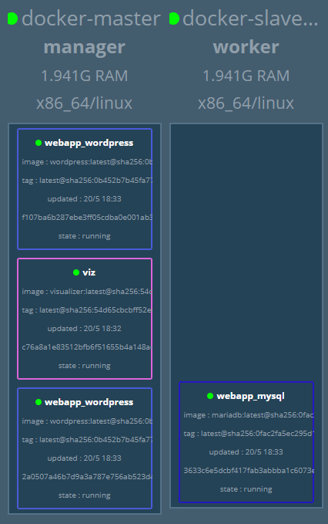List processes: docker stack ps <stack-name> List services: docker service ls

Delete stack: docker stack rm <stack-name>

[https://docs.docker.com/engine/swarm/services/#placement-constrai](https://docs.docker.com/engine/swarm/services/#placement-constraints)g[n](https://docs.docker.com/engine/swarm/services/#placement-constraints)ith[ts](https://docs.docker.com/engine/swarm/services/#placement-constraints)ub.com/kunchalavikram1427

github.com/kunchalavikram1427

# Docker Swarm

### LoadBalancer

* + One of the key benefits of docker swarm is increasing application availability through redundancy
  + Application can be reached from all the available nodes in the cluster using <node-ip>:port
  + But how do end user access this application thorough a common endpoint i.e., DNS name? It is through an External LoadBalancer/Reverse Proxy
  + HAProxy load balancer routes external traffic into the cluster and load balancing its across the available nodes
  + Other popular load balancers include Nginx and Traefik

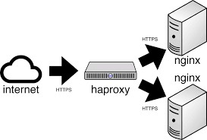

github.com/kunchalavikram1427



Traefik

# Docker Swarm

### HAProxy LoadBalancer

[www.flask-app.com](http://www.flask-app.com/)

github.com/kunchalavikram1427

3



Load Balancer

 10.12.16.22





Round Robin Load balancing

2

1

DNS Server

github.com/kunchalavikram1427

github.com/kunchalavikram1427

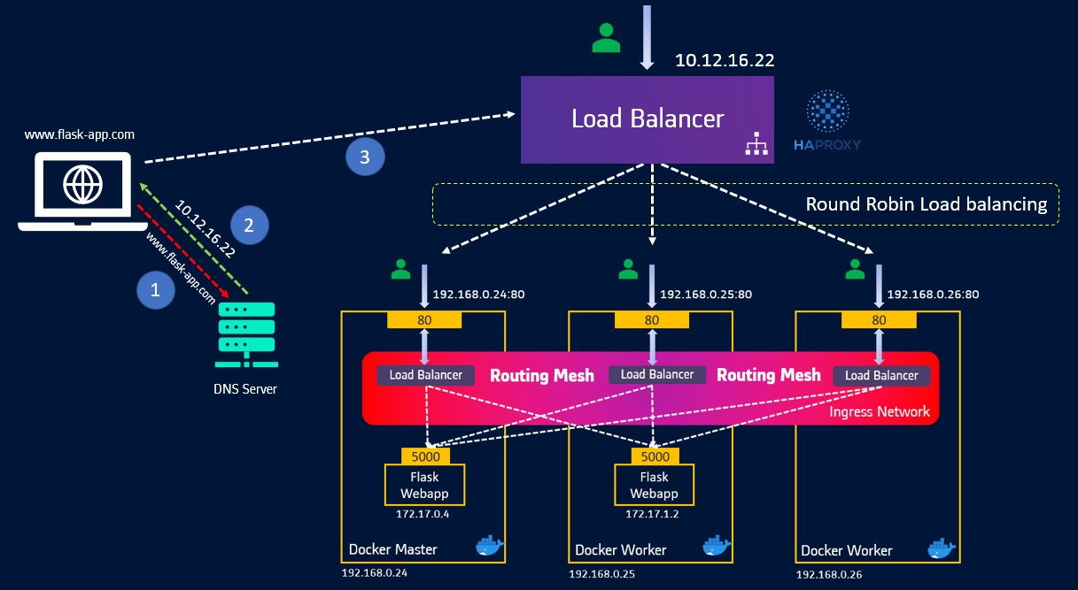

Docker Swarm HAProxy LoadBalancer Demo

1. create a service of 5 flask replicas

docker service create --replicas 5 -p 80:5000

--name web kunchalavikram/sampleflask:v2

1. Create fake DNS entries

(since we don’t have DNS server, we will update

/etc/hosts file in any machine, outside/inside the cluster, with fake DNS name that points to IP of HAProxy server. We will use this name to access the flask application)

3VMs are used for swarm cluster and 1VM for running HAProxy. These are just demo considerations. Not intended for production

github.com/kunchalavikram1427

Docker Swarm HAProxy LoadBalancer Setup HAProxy

* + Provision a VM
  + apt install haproxy –y
  + systemctl stop haproxy
  + add configuration to

/etc/haproxy/haproxy.cfg

* + systemctl start haproxy && systemctl enable haproxy

github.com/kunchalavikram1427



192.168.0.105

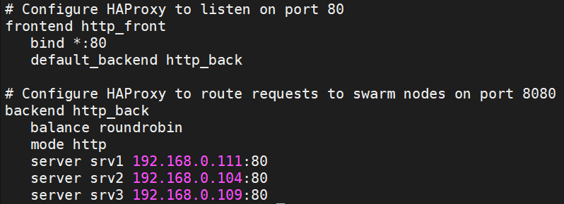

swarm nodes IP and application port

/etc/haproxy/haproxy.cfg

Create a Fake DNS Entry that points to IP of

HAProxy Machine

[http://flaskapp.com](http://flaskapp.com/)



github.com/kunchalavikram1427

linux

windows

/etc/hosts

192.168.0.105 flask-app.com

C:\Windows\System32\drivers\etc\hosts 192.168.0.105 flask-app.com

ipconfig /flushdns

References

* Hypervisors

<https://phoenixnap.com/kb/what-is-hypervisor-type-1-2>

* Docker

<https://takacsmark.com/getting-started-with-docker-in-your-project-step-by-step-tutorial/> <https://container.training/>

* Docker-compose <https://docs.docker.com/compose/compose-file/>

<https://docs.docker.com/compose/compose-file/compose-versioning/>

* Docker Swarm [https://knowledgepill.it/posts/docker_swarm_compendium/?fbclid=IwAR2JWNRHrmfKlauScuEmcW1hwI7IxLJdf6_KUWN8GQiSqxc5pXmkw9RDEaM](https://takacsmark.com/getting-started-with-docker-in-your-project-step-by-step-tutorial/) <https://takacsmark.com/getting-started-with-docker-in-your-project-step-by-step-tutorial/>

<https://container.training/>

<https://rominirani.com/docker-swarm-tutorial-b67470cf8872>

* Docker Networking <https://docs.docker.com/network/network-tutorial-overlay/> <https://docs.docker.com/engine/swarm/ingress/>
* Routing Mesh

<https://mstechbits.wordpress.com/2019/06/06/load-balancing-docker-containers/amp/> [https://techcommunity.microsoft.com/t5/containers/docker-s-routing-mesh-available-with-windows-server-version-1709/ba-p/382382#](https://techcommunity.microsoft.com/t5/containers/docker-s-routing-mesh-available-with-windows-server-version-1709/ba-p/382382) <https://github.com/docker/docker.github.io/blob/master/engine/swarm/networking.md>

* Placement Constraints in Swarm mode <https://docs.docker.com/engine/swarm/services/#placement-constraints>
* Traefik

<https://boxboat.com/2017/10/10/managing-multiple-microservices-with-traefik-in-docker-swarm/> <https://www.digitalocean.com/community/tutorials/how-to-use-traefik-as-a-reverse-proxy-for-docker-containers-on-ubuntu-18-04>

* HAProxy

<https://www.haproxy.com/blog/haproxy-on-docker-swarm-load-balancing-and-dns-service-discovery/>

* GlusterFS

<https://sysadmins.co.za/container-persistent-storage-for-docker-swarm-using-a-glusterfs-volume-plugin/>

<https://medium.com/running-a-software-factory/setup-3-node-high-availability-cluster-with-glusterfs-and-docker-swarm-b4ff80c6b5c3> <https://blog.ruanbekker.com/blog/2019/03/05/setup-a-3-node-replicated-storage-volume-with-glusterfs/?referral=github.com>

* Ceph <https://ceph.io/>

github.com/kunchalavikram1427

# Credits

* + All authors from references section
  + Mumshad Mannambeth’s Free Docker Course on Kodekloud [https://kodekloud.com/p/docker-for- the-absolute-beginner-hands-on](https://kodekloud.com/p/docker-for-the-absolute-beginner-hands-on)
  + YouTube Videos
  + Various blogs

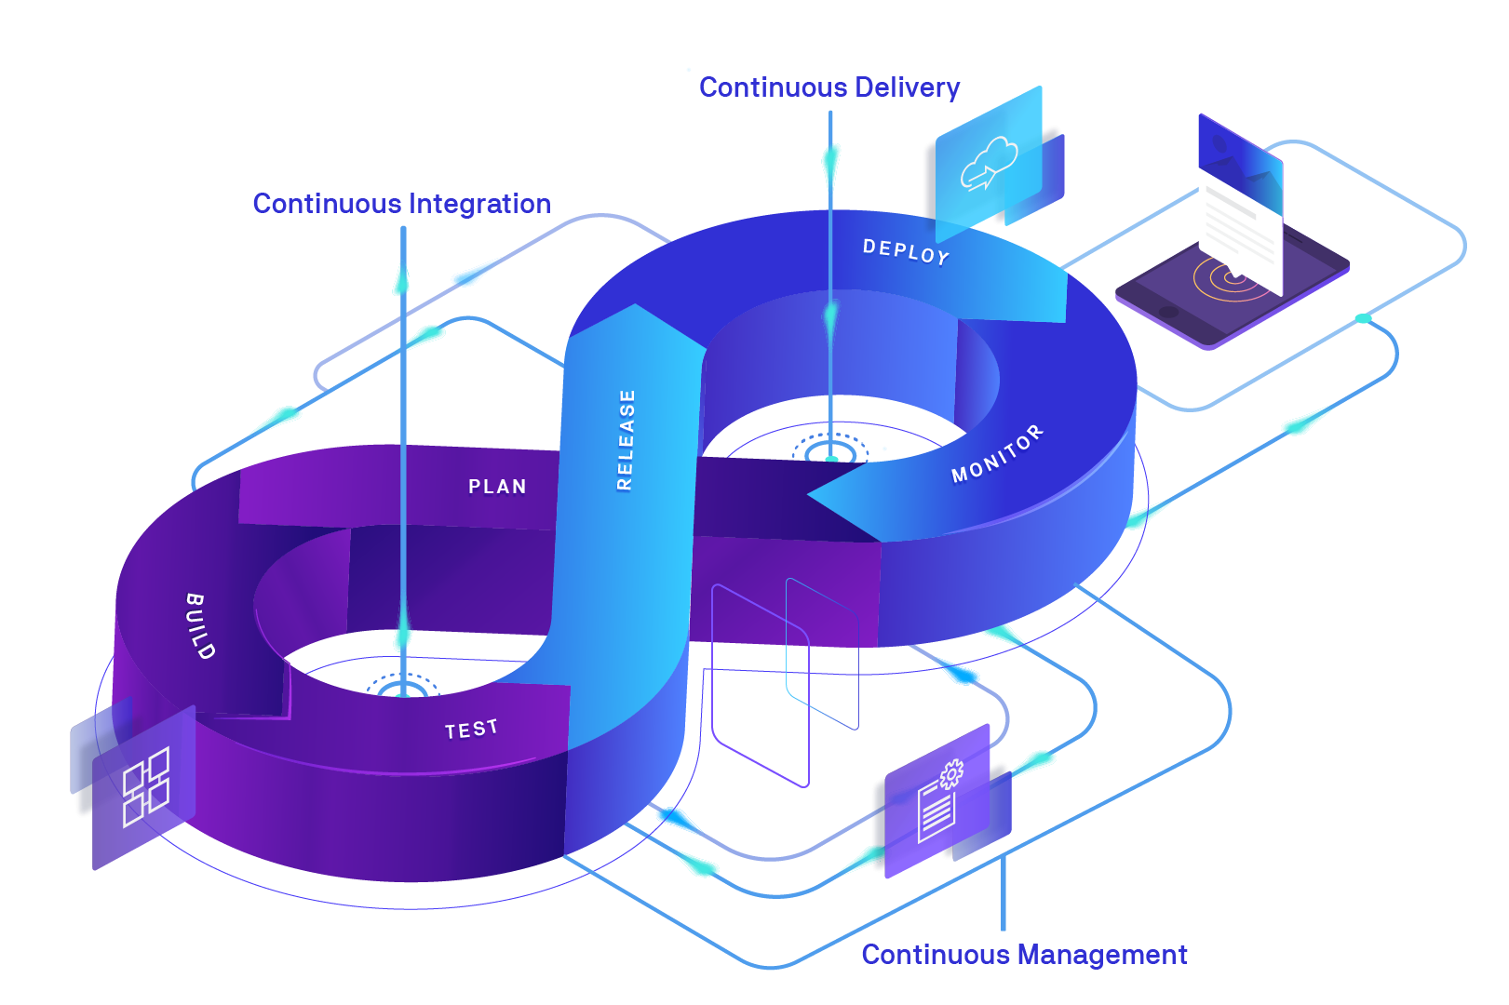

github.com/kunchalavikram1427



github.com/kunchalavikram1427